**Introduction to SQLite**

SQLite is a self-contained, high-reliability, embedded, full-featured, public-domain, SQL database engine. It is the most used database engine in the world. It is an in-process library and its code is publicly available. It is free for use for any purpose, commercial or private. It is basically an embedded SQL database engine. Ordinary disk files can be easily read and write by SQLite because it does not have any separate server like SQL. The SQLite database file format is cross-platform so that anyone can easily copy a database between 32-bit and 64-bit systems. Due to all these features, it is a popular choice as an Application File Format.

**History:**

It was designed by D. Richard Hipp for the purpose of no administration required for operating a program. in August 2000. As it is very lightweight compared to others like MySql and Oracle, it is called SQLite. Different versions of SQLite are released since 2000.

**Installation on Windows:**

1. Visit the official website of SQLite for downloading the zip file.

2. Download that zip file.

3. Create a folder in C or D ( wherever you want ) for storing SQLite by expanding zip file.

4. Open the command prompt and set the path for the location of SQLite folder given in the previous step. After that write “sqlite3” and press enter.

You can also directly open the .exe file from the folder where you have stored the SQLite whole thing.

After clicking on the selected .exe file it will open SQLite application

**Installation on Linux:**

Open Terminal, type this command and enter password

sudo apt-get install sqlite3

**sqlite3**

It will automatically install and once it asks Do you want to continue (Y/N) type Y and press enter. After successful installation, we can check it by command sqlite3.

installation of sqlite3

**Features and Limitation of SQLite**

SQLite is defined by the following features:

**Serverless: –**

 SQLite does not require a server process or system to operate database. The SQLite library accesses its storage files directly.

**Zero Configuration: –**

No server means no setup. SQLite is not required to install any application, configure, and nothing to worry about.

**Cross-Platform: –**

The entire database instance resides in a single cross-platform file, it is not required any administration.

**Self-Contained: –**

A single library contains the entire database system, which integrated directly into a host application.

**Small Runtime Footprint: –**

The default build is less than a megabyte of code and requires only a few megabytes of memory. With some adjustments, both the library size and memory use can be significantly reduced.

**Transactional: –**

SQLite transactions are follows ACID property, it is  allowing safe access from multiple processes or threads.

**Full-Featured: –**

SQLite supports most of the query language features found in the SQL92 (SQL2) standard.

**Highly Reliable: –**

The purpose of a database is to keep your data safe and organized. To maintain a high level – reliability of database, the core SQLite library is tested before each release. In full, the standard SQLite test suites consist of over 10 million-unit tests and query tests.

## Limitations: –

**Foreign key constraints: –**Foreign keys are the foundation of referential integrity in relational databases. While SQLite parses them, it currently does not have support for foreign keys. It does support check constraints, and foreign key support is estimated to be completed by sometime in 2006.

**Trigger support: –**There is some support for triggers but it is not complete. Missing features include FOR EACH STATEMENT triggers (currently all triggers must be FOR EACH ROW), INSTEAD OF triggers on tables (currently INSTEAD OF triggers are only allowed on views), and recursive triggers—triggers that trigger themselves.

**ALTER TABLE support: –** Only the RENAME TABLE and ADD COLUMN variants of the ALTER TABLE command are supported. Other kinds of ALTER TABLE operations such as DROP COLUMN, ALTER COLUMN, and ADD CONSTRAINT are not implemented.

**Nested transactions: –**SQLite allows only a single transaction to be active at one time. Nested transactions allow for fine-grained control over larger, more complex operations in that parts of a transaction can be defined and rolled back in case of an error rather than the entire transaction.

**RIGHT and FULL OUTER JOIN: –** LEFT OUTER JOIN is implemented, but RIGHT OUTER JOIN and FULL OUTER JOIN are not implemented. LEFT OUT JOIN can be implemented as a right outer join by simplified reversing the order of the tables and modify the join constraint. Furthermore, FULL OUTER JOIN can be implemented as a combination of other relational operations supported by SQLite.

**Updatable views: –** VIEWs in SQLite are read-only. You may not execute a DELETE, INSERT, or UPDATE statement on a view. But you can create a trigger that fires on an attempt to DELETE, INSERT, or UPDATE a view and do what you need in the body of the trigger.

**GRANT and REVOKE: –** GRANT and REVOKE commands in general are aimed at much higher end systems where there are multiple users who have varying access levels to data in the database.

SQLite Data Types

**Summary**: in this tutorial, you will learn about SQLite data types system and its related concepts such as storage classes, manifest typing, and type affinity.

Introduction to SQLite data types

If you come from other database systems such as [MySQL](http://www.mysqltutorial.org/mysql-data-types.aspx) and [PostgreSQL](http://www.postgresqltutorial.com/postgresql-data-types/), you notice that they use *static typing*. It means when you declare a column with a specific data type, that column can store only data of the declared data type.

Different from other database systems, SQLite uses *dynamic type system*. In other words, a value stored in a column determines its data type, not the column’s data type.

In addition, you don’t have to declare a specific data type for a column when you create a table. In case you declare a column with the integer data type, you can store any kind of data types such as text and BLOB, SQLite will not complain about this.

SQLite provides five primitive data types which are referred to as *storage classes.*

Storage classes describe the formats that SQLite uses to store data on disk. A storage class is more general than a data type e.g., INTEGER storage class includes 6 different types of integers. In most cases, you can use storage classes and data types interchangeably.

The following table illustrates 5 storage classes in SQLite:

|  |  |
| --- | --- |
| **Storage Class** | **Meaning** |
| NULL | NULL values mean missing information or unknown. |
| INTEGER | Integer values are whole numbers (either positive or negative). An integer can have variable sizes such as 1, 2,3, 4, or 8 bytes. |
| REAL | Real values are real numbers with decimal values that use 8-byte floats. |
| TEXT | TEXT is used to store character data. The maximum length of TEXT is unlimited. SQLite supports various character encodings. |
| BLOB | BLOB stands for a binary large object that can store any kind of data. The maximum size of BLOB is, theoretically, unlimited. |

SQLite determines the data type of a value based on its data type according to the following rules:

* If a literal has no enclosing quotes and decimal point or exponent, SQLite assigns the INTEGER storage class.
* If a literal is enclosed by single or double quotes, SQLite assigns the TEXT storage class.
* If a literal does not have quote nor decimal point nor exponent, SQLite assigns REAL storage class.
* If a literal is NULL without quotes, it assigned NULL storage class.
* If a literal has the X’ABCD’ or x ‘abcd’, SQLite assigned BLOB storage class.

SQLite does not support built-in date and time storage classes. However, you can use the TEXT, INT, or REAL to store date and time values. For the detailed information on how to handle date and time values, check it out the [SQLite date and time tutorial](https://www.sqlitetutorial.net/sqlite-date/).

SQLites provides the typeof() function that allows you to check the storage class of a value based on its format. See the following example:

SELECT

typeof(100),

typeof(10.0),

typeof('100'),

typeof(x'1000'),

typeof(NULL);

Code language: SQL (Structured Query Language) (sql)

SQLite Data Types - typeof function

A single column in SQLite can store mixed data types. See the following example.

First, [create a new table](https://www.sqlitetutorial.net/sqlite-create-table/) named test_datatypes for testing.

CREATE TABLE test_datatypes (

id INTEGER PRIMARY KEY,

val

);

Code language: SQL (Structured Query Language) (sql)

Second, [insert](https://www.sqlitetutorial.net/sqlite-insert/) data into the test_datatypes table.

INSERT INTO test_datatypes (val)

VALUES

(1),

(2),

(10.1),

(20.5),

('A'),

('B'),

(NULL),

(x'0010'),

(x'0011');

Code language: SQL (Structured Query Language) (sql)

Third, use the typeof() function to get the data type of each value stored in the val column.

SELECT

id,

val,

typeof(val)

FROM

test_datatypes;

Code language: SQL (Structured Query Language) (sql)

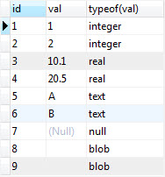

You may ask how SQLite [sorts](https://www.sqlitetutorial.net/sqlite-order-by/)data in a column with different storage classes like val column above.

To resolve this, SQLite provides the following set of rules when it comes to sorting:

* NULL storage class has the lowest value. It is lower than any other values. Between NULL values, there is no order.
* The next higher storage classes are INTEGER and REAL. SQLite compares INTEGER and REAL numerically.
* The next higher storage class is TEXT. SQLite uses the collation of TEXT values when it compares the TEXT values.
* The highest storage class is the BLOB. SQLite uses the C function memcmp() to compare BLOB values.

When you use the [ORDER BY](https://www.sqlitetutorial.net/sqlite-order-by/) clause to sort the data in a column with different storage classes, SQLite performs the following steps:

* First, group values based on storage class: NULL, INTEGER, and REAL, TEXT, and BLOB.
* Second, sort the values in each group.

The following statement sorts the mixed data in the val column of the test_datatypes table:

SELECT

id,

val,

typeof(val)

FROM

test_datatypes

ORDER BY val;

Code language: SQL (Structured Query Language) (sql)

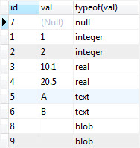

SQLite manifest typing & type affinity

Other important concepts related to SQLite data types are manifest typing and type affinity:

* Manifest typing means that a data type is a property of a value stored in a column, not the property of the column in which the value is stored. SQLite uses manifest typing to store values of any type in a column.
* Type affinity of a column is the recommended type for data stored in that column. Note that the data type is recommended, not required, therefore, a column can store any type of data.

SQLite Transaction

**Summary**: in this tutorial, we will show you how to use the SQLite transaction to ensure the integrity and reliability of the data.

SQLite & ACID

SQLite is a transactional database that all changes and queries are atomic, consistent, isolated, and durable (ACID).

SQLite guarantees all the transactions are ACID compliant even if the transaction is interrupted by a program crash, operation system dump, or power failure to the computer.properties:-

* **A**tomic: a transaction should be atomic. It means that a change cannot be broken down into smaller ones. When you commit a transaction, either the entire transaction is applied or not.
* **C**onsistent: a transaction must ensure to change the database from one valid state to another. When a transaction starts and executes a statement to modify data, the database becomes inconsistent. However, when the transaction is committed or rolled back, it is important that the transaction must keep the database consistent.
* **I**solation: a pending transaction performed by a session must be isolated from other sessions. When a session starts a transaction and executes the [INSERT](https://www.sqlitetutorial.net/sqlite-insert/) or [UPDATE](https://www.sqlitetutorial.net/sqlite-update/) statement to change the data, these changes are only visible to the current session, not others. On the other hand, the changes committed by other sessions after the transaction started should not be visible to the current session.
* Durable: if a transaction is successfully committed, the changes must be permanent in the database regardless of the condition such as power failure or program crash. On the contrary, if the program crashes before the transaction is committed, the change should not persist.

SQLite transaction statements

By default, SQLite operates in auto-commit mode. It means that for each command, SQLite starts, processes, and commits the transaction automatically.

To start a transaction explicitly, you use the following steps:

First, open a transaction by issuing the BEGIN TRANSACTION command.

BEGIN TRANSACTION;

Code language: SQL (Structured Query Language) (sql)

After executing the statement BEGIN TRANSACTION, the transaction is open until it is explicitly committed or rolled back.

Second, issue SQL statements to select or update data in the database. Note that the change is only visible to the current session (or client).

Third, commit the changes to the database by using the COMMIT or COMMIT TRANSACTION statement.

COMMIT;

Code language: SQL (Structured Query Language) (sql)

If you do not want to save the changes, you can roll back using the ROLLBACK or ROLLBACK TRANSACTION statement:

ROLLBACK;

Code language: SQL (Structured Query Language) (sql)

SQLite transaction example

We will create two new tables: accounts and account_changes for the demonstration.

The accounts table stores data about the account numbers and their balances. The account_changes table stores the changes of the accounts.

First, create the accounts and account_changes tables by using the following [CREATE TABLE](https://www.sqlitetutorial.net/sqlite-create-table/) statements:

CREATE TABLE accounts (

account_no INTEGER NOT NULL,

balance DECIMAL NOT NULL DEFAULT 0,

PRIMARY KEY(account_no),

CHECK(balance >= 0)

);

CREATE TABLE account_changes (

change_no INT NOT NULL PRIMARY KEY,

account_no INTEGER NOT NULL,

flag TEXT NOT NULL,

amount DECIMAL NOT NULL,

changed_at TEXT NOT NULL

);

Second, [insert](https://www.sqlitetutorial.net/sqlite-insert/) some sample data into the accounts table.

INSERT INTO accounts (account_no,balance)

VALUES (100,20100);

INSERT INTO accounts (account_no,balance)

VALUES (200,10100);

Third, query data from the accounts table:

SELECT * FROM accounts;

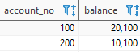

Fourth, transfer 1000 from account 100 to 200, and log the changes to the table account_changes in a single transaction.

BEGIN TRANSACTION;

UPDATE accounts

SET balance = balance - 1000

WHERE account_no = 100;

UPDATE accounts

SET balance = balance + 1000

WHERE account_no = 200;

INSERT INTO account_changes

VALUES(1,100,'-',1000,datetime('now'));

INSERT INTO account_changes

VALUES(2,200,'+',1000,datetime('now'));

COMMIT;

Fifth, query data from the accounts table:

SELECT * FROM accounts;



As you can see, balances have been updated successfully.

Sixth, query the contents of the account_changes table:

SELECT * FROM account_changes;

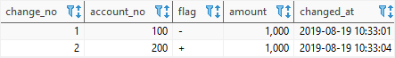

Let’s take another example of rolling back a transaction.

First, attempt to deduct 20,000 from account 100:

BEGIN TRANSACTION;

UPDATE accounts

SET balance = balance - 20000

WHERE account_no = 100;

INSERT INTO account_changes(account_no,flag,amount,changed_at)

VALUES(100,'-',20000,datetime('now'));

SQLite issued an error due to not enough balance:

[SQLITE_CONSTRAINT] Abort due to constraint violation (CHECK constraint failed: accounts)

However, the log has been saved to the account_changes table:

SELECT * FROM account_changes;

Code language: SQL (Structured Query Language) (sql)

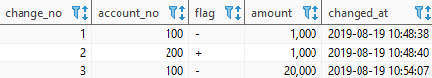

Second, roll back the transaction by using the ROLLBACK statement:

ROLLBACK;

Finally, query data from the account_changes table, you will see that the change no #3 is not there anymore:

SELECT * FROM account_changes;

Code language: SQL (Structured Query Language) (sql)

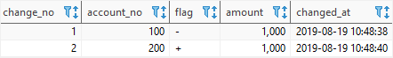

# How to create and open Database

.open databasse1.db

### **Filtering data**

# SQLite Select Distinct

**Summary**: in this tutorial, you will learn how to use the SQLite SELECT DISTINCT clause to remove duplicate rows in the result set.

## Introduction to SQLite SELECT DISTINCT clause

The DISTINCT clause is an optional clause of the  [SELECT](https://www.sqlitetutorial.net/sqlite-select/) statement. The DISTINCT clause allows you to remove the duplicate rows in the result set.

The following statement illustrates the syntax of the DISTINCT clause:

SELECT DISTINCT select_list

FROM table;

In this syntax:

* First, the DISTINCT clause must appear immediately after the SELECT keyword.
* Second, you place a column or a list of columns after the DISTINCT keyword. If you use one column, SQLite uses values in that column to evaluate the duplicate. In case you use multiple columns, SQLite uses the combination of values in these columns to evaluate the duplicate.

SQLite considers NULL values as duplicates. If you use theDISTINCT clause with a column that has NULL values, SQLite will keep one row of a NULL value.

In database theory, if a column contains NULL values, it means that we do not have the information about that column of particular records or the information is not applicable.

For example, if a customer has a phone number with a NULL value, it means we don’t have information about the phone number of the customer at the time of recording customer information or the customer may not have a phone number at all.

## SQLite SELECT DISTINCT examples

We will use the customers table in the [sample database](https://www.sqlitetutorial.net/sqlite-sample-database/) for demonstration.

CREATE TABLE COMPANY(

ID INT PRIMARY KEY NOT NULL,

NAME TEXT NOT NULL,

AGE INT NOT NULL,

ADDRESS CHAR(50),

SALARY REAL,

CITY TEXT

);

INSERT INTO COMPANY (ID,NAME,AGE,ADDRESS,SALARY,CITY)

VALUES (1, 'Paul', 32, 'California', 20000.00 , ‘SURAT’);

INSERT INTO COMPANY (ID,NAME,AGE,ADDRESS,SALARY,CITY)

VALUES (2, 'Allen', 25, 'Texas', 15000.00,’MUMBAI’ );

INSERT INTO COMPANY (ID,NAME,AGE,ADDRESS,SALARY,CITY)

VALUES (3, 'Teddy', 23, 'Norway', 20000.00, ‘SURAT’ );

INSERT INTO COMPANY (ID,NAME,AGE,ADDRESS,SALARY,CITY)

VALUES (4, 'Mark', 25, 'Rich-Mond ', 65000.00, ’MUMBAI’ );

INSERT INTO COMPANY (ID,NAME,AGE,ADDRESS,SALARY,CITY)

VALUES (5, 'David', 27, 'Texas', 85000.00, ‘SURAT’);

INSERT INTO COMPANY (ID,NAME,AGE,ADDRESS,SALARY,CITY)

VALUES (6, 'Kim', 22, 'South-Hall', 45000.00, ’MUMBAI’);

Suppose you want to know the cities where the customers locate, you can use the SELECT statement to get data from the city column of the customers table as follows:

SELECT city

FROM customers

ORDER BY city;

To remove these duplicate rows, you use the DISTINCT clause as follows:

SELECT DISTINCT city

FROM customers

ORDER BY city;

### **SQLite SELECT DISTINCT on multiple columns**

The following statement finds cities and countries of all customers.

SELECT

city,

country

FROM

customers

ORDER BY

country;

The result set contains duplicate city and country e.g., Sao Paulo in Brazil as shown in the screenshot above.

To remove duplicate the city and country, you apply the DISTINCT clause to both city and country columns as shown in the following query:

SELECT DISTINCT

city,

country

FROM

customers

ORDER BY

country;

As mentioned earlier, SQLite uses the combination of city and country to evaluate the duplicate.

### **SQLite SELECT DISTINCT with NULL example**

This statement returns the names of companies of customers from the customers table.

SELECT company

FROM customers;

Now, if you apply the DISTINCT clause to the statement, it will keep only one row with a NULL value.

See the following statement:

SELECT DISTINCT company

FROM customers;

Note that if you select a list of columns from a table and want to get a unique combination of some columns, you can use the [GROUP BY](https://www.sqlitetutorial.net/sqlite-group-by/) clause.

# SQLite Where

## Introduction to SQLite WHERE clause

The WHERE clause is an optional clause of the [SELECT](https://www.sqlitetutorial.net/sqlite-select/) statement. It appears after the FROM clause as the following statement:

SELECT

column_list

FROM

table

WHERE

search_condition;

In this example, you add a WHERE clause to the SELECT statement to filter rows returned by the query. When evaluating a SELECT statement with a WHERE clause, SQLite uses the following steps:

1. First, check the table in the FROM clause.
2. Second, evaluate the conditions in the WHERE clause to get the rows that met these conditions.
3. Third, make the final result set based on the rows in the previous step with columns in the SELECT clause.

The search condition in the WHERE has the following form:

left_expression COMPARISON_OPERATOR right_expression

For example, you can form a search condition as follows:

WHERE column_1 = 100;

WHERE column_2 IN (1,2,3);

WHERE column_3 LIKE 'An%';

WHERE column_4 BETWEEN 10 AND 20;

Besides the SELECT statement, you can use the WHERE clause in the [UPDATE](https://www.sqlitetutorial.net/sqlite-update/) and [DELETE](https://www.sqlitetutorial.net/sqlite-delete/) statements.

### **SQLite comparison operators**

A comparison operator tests if two expressions are the same. The following table illustrates the comparison operators that you can use to construct expressions:

| **Operator** | **Meaning** |
| --- | --- |
| = | Equal to |
| <> or != | Not equal to |
| < | Less than |
| > | Greater than |
| <= | Less than or equal to |
| >= | Greater than or equal to |

### **SQLite logical operators**

Logical operators allow you to test the truth of some expressions. A logical operator returns 1, 0, or a NULL value.

Notice that SQLite does not provide Boolean data type therefore 1 means TRUE, and 0 means FALSE.

The following table illustrates the SQLite logical operators:

|  |  |
| --- | --- |
| **Operator** | **Meaning** |
| ALL | returns 1 if all expressions are 1. |
| AND | returns 1 if both expressions are 1, and 0 if one of the expressions is 0. |
| ANY | returns 1 if any one of a set of comparisons is 1. |
| [BETWEEN](https://www.sqlitetutorial.net/sqlite-between/) | returns 1 if a value is within a range. |
| [EXISTS](https://www.sqlitetutorial.net/sqlite-exists/) | returns 1 if a subquery contains any rows. |
| [IN](https://www.sqlitetutorial.net/sqlite-in/) | returns 1 if a value is in a list of values. |
| [LIKE](https://www.sqlitetutorial.net/sqlite-like/) | returns 1 if a value matches a pattern |
| NOT | reverses the value of other operators such as NOT EXISTS, NOT IN, NOT BETWEEN, etc. |
| OR | returns true if either expression is 1 |

## SQLite WHERE clause examples

We will use the tracks table in the [sample database](https://www.sqlitetutorial.net/sqlite-sample-database/) to illustrate how to use the WHERE clause.

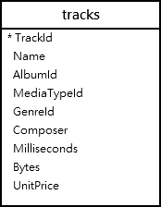

The equality operator (=) is the most commonly used operator. For example, the following query uses the WHERE clause the equality operator to find all the tracks in the album id 1:

SELECT

name,

milliseconds,

bytes,

albumid

FROM

tracks

WHERE

albumid = 1;

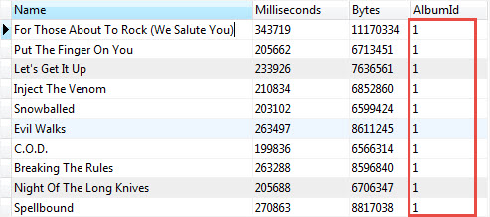

SQLite compares the values stored in the AlbumId column with a literal value 1 to test if they are equal. Only the rows that satisfy the condition are returned.

When you compare two values, you must ensure that they are the same data type. You should compare numbers with numbers, string with strings, etc.

In case you compare values in different data types e.g., a string with a number, SQLite has to perform implicit data type conversions, but in general, you should avoid doing this.

You use the logical operator to combine expressions. For example, to get tracks of the album 1 that have the length greater than 200,000 milliseconds, you use the following statement:

SELECT

name,

milliseconds,

bytes,

albumid

FROM

tracks

WHERE

albumid = 1

AND milliseconds > 250000;

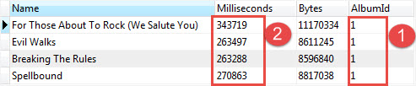

The statement used two expressions albumid = 1 and milliseconds > 250000. It uses the AND logical operator to combine these expressions.

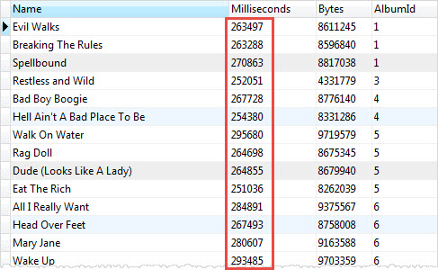

### **SQLite WHERE clause with LIKE operator example**

Sometimes, you may not remember exactly the data that you want to search. In this case, you perform an inexact search using the [LIKE](https://www.sqlitetutorial.net/sqlite-like/) operator.

For example, to find which tracks composed by Smith, you use the LIKE operator as follows:

SELECT

name,

albumid,

composer

FROM

tracks

WHERE

composer LIKE '%Smith%'

ORDER BY

albumid;

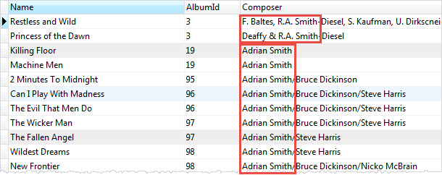

You get tracks composed by R.A. Smith-Diesel, Adrian Smith, etc.

### **SQLite WHERE clause with the IN operator example**

The [IN](https://www.sqlitetutorial.net/sqlite-in/) operator allows you to check whether a value is in a list of a comma-separated list of values. For example, to find tracks that have media type id is 2 or 3, you use the IN operator as shown in the following statement:

SELECT

name,

albumid,

mediatypeid

FROM

tracks

WHERE

mediatypeid IN (4, 5);

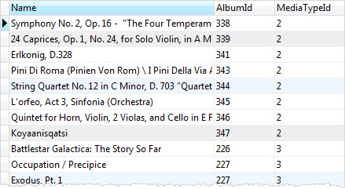

# SQLite Limit

## Introduction to SQLite LIMIT clause

The LIMIT clause is an optional part of the  [SELECT](https://www.sqlitetutorial.net/sqlite-select/) statement. You use the LIMIT clause to constrain the number of rows returned by the query.

For example, a SELECT statement may return one million rows. However, if you just need the first 10 rows in the result set, you can add the LIMIT clause to the SELECT statement to retrieve 10 rows.

The following illustrates the syntax of the LIMIT clause.

SELECT

column_list

FROM

table

LIMIT row_count;

The row_count is a positive integer that specifies the number of rows returned.

For example, to get the first 10 rows in the tracks table, you use the following statement:

SELECT

trackId,

name

FROM

tracks

LIMIT 10;

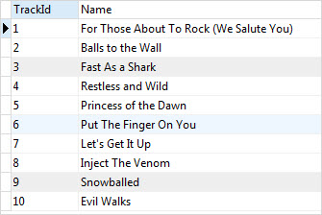

If you want to get the first 10 rows starting from the 10th row of the result set, you use OFFSET keyword as the following:

SELECT

column_list

FROM

table

LIMIT row_count OFFSET offset;

Or you can use the following shorthand syntax of the LIMIT OFFSET clause:

SELECT

column_list

FROM

table

LIMIT offset, row_count;

For example, to get 10 rows starting from the 11th row in the tracks table, you use the following statement:

SELECT

trackId,

name

FROM

tracks

LIMIT 10 OFFSET 10;

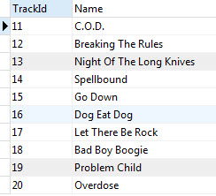

You often find the uses of OFFSET in web applications for paginating result sets.

## SQLite LIMIT and ORDER BY clause

You should always use the LIMIT clause with the  ORDER BY clause. Because you want to get a number of rows in a specified order, not in an unspecified order.

The ORDER BY clause appears before the LIMIT clause in the SELECT statement. SQLite sorts the result set before getting the number of rows specified in the LIMIT clause.

SELECT

column_list

FROM

table

ORDER BY column_1

LIMIT row_count;

For example, to get the top 10 biggest tracks by size, you use the following query:

SELECT

trackid,

name,

bytes

FROM

tracks

ORDER BY

bytes DESC

LIMIT 10;

[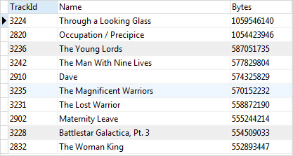](https://www.sqlitetutorial.net/wp-content/uploads/2015/11/SQLite-LIMIT-Top-10-Largest-Tracks.jpg)

To get the 5 shortest tracks, you sort the tracks by the length specified by milliseconds column using ORDER BY clause and get the first 5 rows using LIMIT clause.

SELECT

trackid,

name,

milliseconds

FROM

tracks

ORDER BY

milliseconds ASC

LIMIT 5;

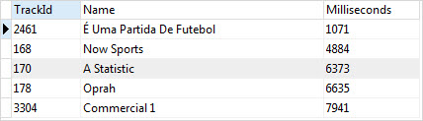

### **Getting the nth highest and the lowest value**

You can use the ORDER BY and LIMIT clauses to get the nth highest or lowest value rows. For example, you may want to know the second-longest track, the third smallest track, etc.

To do this, you use the following steps:

1. First, use ORDER BY to sort the result set in ascending order in case you want to get the nth lowest value, or descending order if you want to get the nth highest value.
2. Second, use the LIMIT OFFSET clause to get the nth highest or the nth lowest row.

The following statement returns the second-longest track in the tracks table.

SELECT

trackid,

name,

milliseconds

FROM

tracks

ORDER BY

milliseconds DESC

LIMIT 1 OFFSET 1;

[SQLite LIMIT second longest track](https://www.sqlitetutorial.net/wp-content/uploads/2015/11/SQLite-LIMIT-second-longest-track.jpg)

The following statement gets the third smallest track on the tracks table.

SELECT

trackid,

name,

bytes

FROM

tracks

ORDER BY

bytes

LIMIT 1 OFFSET 2;

[SQLite LIMIT third smallest track](https://www.sqlitetutorial.net/wp-content/uploads/2015/11/SQLite-LIMIT-third-smallest-track.jpg)

In this tutorial, you have learned how to use SQLite LIMIT clause to constrain the number of rows returned by the query.

# SQLite BETWEEN

**Summary**: in this tutorial, you will learn how to use the SQLite BETWEEN operator to test whether a value is in a range of values.

## Introduction to SQLite BETWEEN Operator

The BETWEEN operator is a logical operator that tests whether a value is in range of values. If the value is in the specified range, the BETWEEN operator returns true. The BETWEEN operator can be used in the [WHERE](https://www.sqlitetutorial.net/sqlite-where/) clause of the [SELECT](https://www.sqlitetutorial.net/sqlite-select/), [DELETE](https://www.sqlitetutorial.net/sqlite-delete/), [UPDATE](https://www.sqlitetutorial.net/sqlite-update/), and [REPLACE](https://www.sqlitetutorial.net/sqlite-replace-statement/) statements.

The following illustrates the syntax of the SQLite BETWEEN operator:

test_expression BETWEEN low_expression AND high_expression

In this syntax:

* test_expression is an expression to test for in the range defined by low_expression and high_expression.
* low_expression and high_expression is any valid expression that specify the low and high values of the range. The low_expression should be less than or equal to high_expression, or the BETWEEN is always returns false.
* The AND keyword is a placeholder which indicates the test_expression should be within the range specified by low_expression and high_expression.

Note that the BETWEEN operator is inclusive. It returns true when the test_expression is less than or equal to high_expression and greater than or equal to the value of low_expression:

test_expression >= low_expression AND test_expression <= high_expression

To specify an exclusive range, you use the greater than (>) and less than operators (<).

Note that if any input to the BETWEEN operator is NULL, the result is NULL, or unknown to be precise.

To negate the result of the BETWEEN operator, you use the NOT BETWEEN operator as follows:

test_expression NOT BETWEEN low_expression AND high_expression

The NOT BETWEEN returns true if the value of test_expression is less than the value of low_expression or greater than the value of high_expression:

test_expression < low_expression OR test_expression > high_expression

## SQLite BETWEEN operator examples

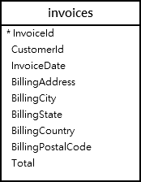

### **SQLite BETWEEN numeric values example**

The following statement finds invoices whose total is between 14.96 and 18.86:

SELECT

InvoiceId,

BillingAddress,

Total

FROM

invoices

WHERE

Total BETWEEN 14.91 and 18.86

ORDER BY

Total;

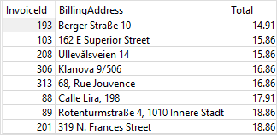

As you can see, the invoices whose total is 14.91 or 18.86 are included in the result set.

### **SQLite NOT BETWEEN numeric values example**

To find the invoices whose total are not between 1 and 20, you use the NOT BETWEEN operator as shown in the following query:

SELECT

InvoiceId,

BillingAddress,

Total

FROM

invoices

WHERE

Total NOT BETWEEN 1 and 20

ORDER BY

Total;

The following picture shows the output:

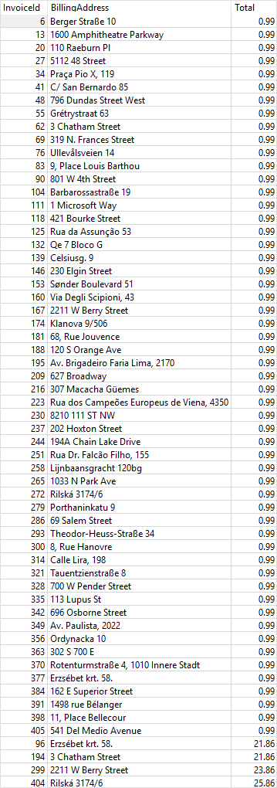

As clearly shown in the output, the result includes the invoices whose total is less than 1 and greater than 20.

### **SQLite BETWEEN dates example**

The following example finds invoices whose invoice dates are from January 1 2010 and January 31 2010:

SELECT

InvoiceId,

BillingAddress,

InvoiceDate,

Total

FROM

invoices

WHERE

InvoiceDate BETWEEN '2010-01-01' AND '2010-01-31'

ORDER BY

InvoiceDate;

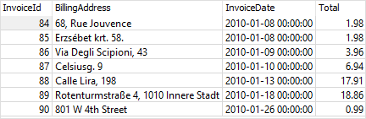

### **SQLite NOT BETWEEN dates example**

The following statement finds invoices whose dates are not between January 03, 2009, and December 01, 2013:

SELECT

InvoiceId,

BillingAddress,

date(InvoiceDate) InvoiceDate,

Total

FROM

invoices

WHERE

InvoiceDate NOT BETWEEN '2009-01-03' AND '2013-12-01'

ORDER BY

InvoiceDate;

The output is as follows:

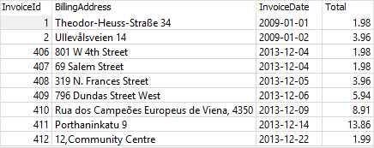

# SQLite IN

**Summary**: in this tutorial, you will learn how to use the SQLite IN operator to determine whether a value matches any value in a list of values or a result of a subquery.

## Introduction to the SQLite IN operator

The SQLite IN operator determines whether a value matches any value in a list or a [subquery](https://www.sqlitetutorial.net/sqlite-subquery/). The syntax of the IN operator is as follows:

expression [NOT] IN (value_list|subquery);

The expression can be any valid expression or a column of a table.

A list of values is a fixed value list or a result set of a single column returned by a subquery. The returned [type](https://www.sqlitetutorial.net/sqlite-data-types/) of expression and values in the list must be the same.

The IN operator returns true or false depending on whether the expression matches any value in a list of values or not. To negate the list of values, you use the NOT IN operator.

## SQLite IN operator examples



The following statement uses the IN operator to query the tracks whose media type id is 1 or 2.

SELECT

TrackId,

Name,

Mediatypeid

FROM

Tracks

WHERE

MediaTypeId IN (4, 5)

ORDER BY

Name ASC;

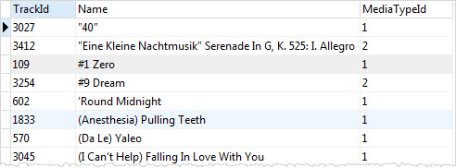

This query uses the OR operator instead of the IN operator to return the same result set as the above query:

SELECT

TrackId,

Name,

MediaTypeId

FROM

Tracks

WHERE

MediaTypeId = 1 OR MediaTypeId = 2

ORDER BY

Name ASC;

As you can see from the queries, using the IN operator is much shorter.

If you have a query that uses many OR operators, you can consider using the IN operator instead to make the query more readable.

### **SQLite IN operator with a subquery example**

The following query returns a list of album id of the artist id 12:

SELECT albumid

FROM albums

WHERE artistid = 12;

SQLite IN with subquery example

To get the tracks that belong to the artist id 12, you can combine the IN operator with a [subquery](https://www.sqlitetutorial.net/sqlite-subquery/) as follows:

SELECT

TrackId,

Name,

AlbumId

FROM

Tracks

WHERE

AlbumId IN (

SELECT

AlbumId

FROM

Albums

WHERE

ArtistId = 12

);

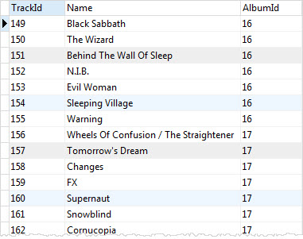

In this example:

* First, the subquery returns a list of album ids that belong to the artist id 12.
* Then, the outer query return all tracks whose album id matches with the album id list returned by the subquery.

### **SQLite NOT IN examples**

The following statement returns a list of tracks whose genre id is not in a list of (1,2,3).

SELECT

trackid,

name,

genreid

FROM

tracks

WHERE

genreid NOT IN (1, 2,3);

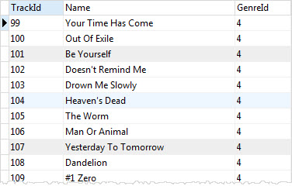

# SQLite LIKE

**Summary**: in this tutorial, you will learn how to query data based on pattern matching using SQLite LIKE operator.

## Introduction to SQLite LIKE operator

Sometimes, you don’t know exactly the complete keyword that you want to query. For example, you may know that your most favorite song contains the word,elevator but you don’t know exactly the name.

To [query data](https://www.sqlitetutorial.net/sqlite-select/) based on partial information, you use the LIKE operator in the [WHERE](https://www.sqlitetutorial.net/sqlite-where/) clause of the [SELECT](https://www.sqlitetutorial.net/sqlite-select/) statement as follows:

SELECT

column_list

FROM

table_name

WHERE

column_1 LIKE pattern;

Note that you can also use the LIKE operator in the WHERE clause of other statements such as the DELETE and UPDATE.

SQLite provides two wildcards for constructing patterns. They are percent sign % and underscore __:

1. The percent sign % wildcard matches any sequence of zero or more characters.
2. The underscore _ wildcard matches any single character.

### **The percent sign % wildcard examples**

The s% pattern that uses the percent sign wildcard ( %) matches any string that starts with s e.g.,son and so.

The %er pattern matches any string that ends with er like peter, clever, etc.

And the %per% pattern matches any string that contains per such as percent and peeper.

### **The underscore _ wildcard examples**

The h_nt pattern matches hunt, hint, etc. The __pple pattern matches topple, supple, tipple, etc.  
Note that SQLite LIKE operator is case-insensitive. It means "A" LIKE "a" is true.

However, for Unicode characters that are not in the ASCII ranges, the LIKE operator is case sensitive e.g., "Ä" LIKE "ä" is false.  
In case you want to make LIKE operator works case-sensitively, you need to use the following [PRAGMA](https://www.sqlite.org/pragma.html#pragma_case_sensitive_like):

PRAGMA case_sensitive_like = true;

Code language: SQL (Structured Query Language) (sql)

## SQLite LIKE examples

We’ll use the table tracks in the [sample database](https://www.sqlitetutorial.net/sqlite-sample-database/) for the demonstration.



To find the tracks whose names start with the Wild literal string, you use the percent sign % wildcard at the end of the pattern.

SELECT

trackid,

name

FROM

tracks

WHERE

name LIKE 'Wild%'

Code language: SQL (Structured Query Language) (sql)

[**Try It**](https://www.sqlitetutorial.net/tryit/query/sqlite-like/#1)

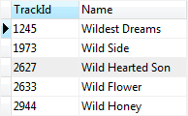

To find the tracks whose names end with Wild word, you use % wildcard at the beginning of the pattern.

SELECT

trackid,

name

FROM

tracks

WHERE

name LIKE '%Wild'

Code language: SQL (Structured Query Language) (sql)

[**Try It**](https://www.sqlitetutorial.net/tryit/query/sqlite-like/#2)

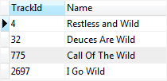

To find the tracks whose names contain the Wild literal string, you use % wildcard at the beginning and end of the pattern:

SELECT

trackid,

name

FROM

tracks

WHERE

name LIKE '%Wild%';

Code language: SQL (Structured Query Language) (sql)

[**Try It**](https://www.sqlitetutorial.net/tryit/query/sqlite-like/#3)

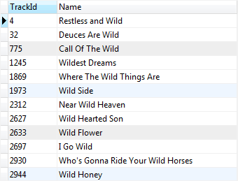

The following statement finds the tracks whose names contain: zero or more characters (%), followed by Br, followed by a character ( _), followed by wn, and followed by zero or more characters ( %).

SELECT

trackid,

name

FROM

tracks

WHERE

name LIKE '%Br_wn%';

Code language: SQL (Structured Query Language) (sql)

[**Try It**](https://www.sqlitetutorial.net/tryit/query/sqlite-like/#4)

## SQLite LIKE with ESCAPE clause

If the pattern that you want to match contains % or _, you must use an escape character in an optional ESCAPE clause as follows:

column_1 LIKE pattern ESCAPE expression;

Code language: SQL (Structured Query Language) (sql)

When you specify the ESCAPE clause, the LIKE operator will evaluate the expression that follows the ESCAPE keyword to a string which consists of a single character, or an escape character.

Then you can use this escape character in the pattern to include literal percent sign (%) or underscore (_).  The LIKE operator evaluates the percent sign (%) or underscore (_) that follows the escape character as a literal string, not a wildcard character.

Suppose you want to match the string 10% in a column of a table. However, SQLite interprets the percent symbol % as the wildcard character. Therefore,  you need to escape this percent symbol % using an escape character:

column_1 LIKE '%10\%%' ESCAPE '\';

Code language: SQL (Structured Query Language) (sql)

In this expression, the LIKE operator interprets the first % and last % percent signs as wildcards and the second percent sign as a literal percent symbol.

Note that you can use other characters as the escape character e.g., /, @, $.

Consider the following example:

First, [create a table](https://www.sqlitetutorial.net/sqlite-create-table/) t that has one column:

CREATE TABLE t(

c TEXT

);

Code language: SQL (Structured Query Language) (sql)

Next, [insert](https://www.sqlitetutorial.net/sqlite-insert/) some rows into the table t:

INSERT INTO t(c)

VALUES('10% increase'),

('10 times decrease'),

('100% vs. last year'),

('20% increase next year');

Code language: SQL (Structured Query Language) (sql)

Then, query data from the t table:

SELECT * FROM t;

Code language: SQL (Structured Query Language) (sql)

c

----------------------

10% increase

10 times decrease

100% vs. last year

20% increase next year

Code language: Shell Session (shell)

Fourth, attempt to find the row whose value in the c column contains the 10% literal string:

SELECT c

FROM t

WHERE c LIKE '%10%%';

Code language: SQL (Structured Query Language) (sql)

However, it returns rows whose values in the c column contains 10:

c

------------------

10% increase

10 times decrease

100% vs. last year

Fifth, to get the correct result, you use the ESCAPE clause as shown in the following query:

SELECT c

FROM t

WHERE c LIKE '%10\%%' ESCAPE '\';

Code language: SQL (Structured Query Language) (sql)

Here is the result set:

c

------------

10% increase

# SQLite IS NULL

**Summary**: in this tutorial, you will learn how to use the SQLite IS NULL and IS NOT NULL operators to check whether a value is NULL or not.

## Introduction to the SQLite IS NULL operator

NULL is special. It indicates that a piece of information is unknown or not applicable.

For example, some songs may not have the songwriter information because we don’t know who wrote them.

To store these unknown songwriters along with the songs in a database table, we must use NULL.

NULL is not equal to anything even the number zero, an empty string, and so on.

Especially, NULL is not equal to itself. The following expression returns 0:

NULL = NULL

Code language: SQL (Structured Query Language) (sql)

This is because two unknown information cannot be comparable.

Let’s see the following tracks table from the [sample database](https://www.sqlitetutorial.net/sqlite-sample-database/):



The following statement attempts to find tracks whose composers are NULL:

SELECT

Name,

Composer

FROM

tracks

WHERE

Composer = NULL;

Code language: SQL (Structured Query Language) (sql)

It returns an empty row without issuing any additional message.

This is because the following expression always evaluates to false:

Composer = NULL

Code language: SQL (Structured Query Language) (sql)

It’s not valid to use the NULL this way.

To check if a value is NULL or not, you use the IS NULL operator instead:

{ column | expression } IS NULL;

Code language: SQL (Structured Query Language) (sql)

The IS NULL operator returns 1 if the column or expression evaluates to NULL.

To find all tracks whose composers are unknown, you use the IS NULL operator as shown in the following query:

SELECT

Name,

Composer

FROM

tracks

WHERE

Composer IS NULL

ORDER BY

Name;

Code language: SQL (Structured Query Language) (sql)

Here is the partial output:

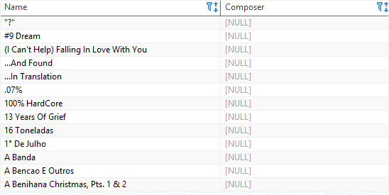

## SQLite IS NOT NULL operator

The NOT operator negates the IS NULL operator as follows:

expression | column IS NOT NULL

Code language: SQL (Structured Query Language) (sql)

The IS NOT NULL operator returns 1 if the expression or column is not NULL, and 0 if the expression or column is NULL.

The following example finds tracks whose composers are not NULL:

SELECT

Name,

Composer

FROM

tracks

WHERE

Composer IS NOT NULL

ORDER BY

Name;

SQLite GLOB

**Summary**: in this tutorial, you will learn how to use the SQLite GLOB operator to determine whether a string matches a specific pattern.

Introduction to the SQLite GLOB operator

The GLOB operator is similar to the [LIKE](https://www.sqlitetutorial.net/sqlite-like/) operator. The GLOB operator determines whether a string matches a specific pattern.

Unlike the LIKE operator, the GLOB operator is **case sensitive** and uses the **UNIX wildcards.**In addition, the GLOB patterns do not have escape characters.

The following shows the wildcards used with the GLOB  operator:

* The asterisk (*) wildcard matches any number of characters.
* The question mark (?) wildcard matches exactly one character.

On top of these wildcards, you can use the list wildcard [] to match one character from a list of characters. For example [xyz] match any single x, y, or z character.

The list wildcard also allows a range of characters e.g., [a-z] matches any single lowercase character from a to z. The [a-zA-Z0-9] pattern matches any single alphanumeric character, both lowercase, and uppercase.

Besides, you can use the character ^ at the beginning of the list to match any character except for any character in the list. For example, the [^0-9] pattern matches any single character except a numeric character.

SQLite GLOB examples

The following statement finds tracks whose names start with the string Man. The pattern Man* matches any string that starts with Man.

SELECT

trackid,

name

FROM

tracks

WHERE

name GLOB 'Man*';

Code language: SQL (Structured Query Language) (sql)

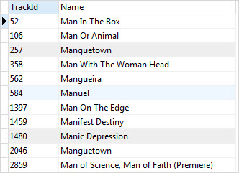

The following statement gets the tracks whose names end with Man. The pattern *Man matches any string that ends with Man.

SELECT

trackid,

name

FROM

tracks

WHERE

name GLOB '*Man';

Code language: SQL (Structured Query Language) (sql)

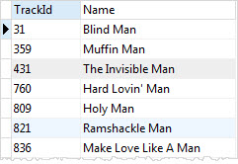

The following query finds the tracks whose names start with any single character (?), followed by the string ere and then any number of character (*).

SELECT

trackid,

name

FROM

tracks

WHERE

name GLOB '?ere*';

Code language: SQL (Structured Query Language) (sql)

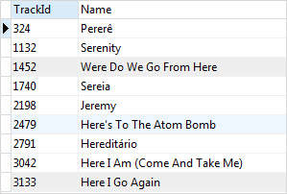

To find the tracks whose names contain numbers, you can use the list wildcard [0-9] as follows:

SELECT

trackid,

name

FROM

tracks

WHERE

name GLOB '*[1-9]*';

Code language: SQL (Structured Query Language) (sql)

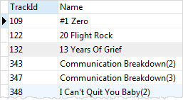

Or to find the tracks whose name does not contain any number, you place the character ^ at the beginning of the list:

SELECT

trackid,

name

FROM

tracks

WHERE

name GLOB '*[^1-9]*';

Code language: SQL (Structured Query Language) (sql)



The following statement finds the tracks whose names end with a number.

SELECT

trackid,

name

FROM

tracks

WHERE

name GLOB '*[1-9]';

Code language: SQL (Structured Query Language) (sql)

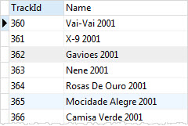

**Set operators**

# SQLite Union

**Summary**: in this tutorial, you will learn how to use SQLite UNION operator to combine result sets of two or more queries into a single result set.

## Introduction to SQLite UNION operator

Sometimes, you need to combine data from multiple tables into a complete result set. It may be for tables with similar data within the same database or maybe you need to combine similar data from multiple databases.

To combine rows from two or more [queries](https://www.sqlitetutorial.net/sqlite-select/) into a single result set, you use SQLite UNION operator. The following illustrates the basic syntax of the UNION operator:

query_1

UNION [ALL]

query_2

UNION [ALL]

query_3

...;

Code language: SQL (Structured Query Language) (sql)

Both UNION and UNION ALL operators combine rows from result sets into a single result set. The UNION operator removes eliminate duplicate rows, whereas the UNION ALL operator does not.

Because the UNION ALL operator does not remove duplicate rows, it runs faster than the UNION operator.

The following are rules to union data:

* The number of columns in all queries must be the same.
* The corresponding columns must have compatible data types.
* The column names of the first query determine the column names of the combined result set.
* The [GROUP BY](https://www.sqlitetutorial.net/sqlite-group-by/) and [HAVING](https://www.sqlitetutorial.net/sqlite-having/) clauses are applied to each individual query, not the final result set.
* The [ORDER BY](https://www.sqlitetutorial.net/sqlite-order-by/) clause is applied to the combined result set, not within the individual result set.

Note that the difference between UNION and JOIN e.g., [INNER JOIN](https://www.sqlitetutorial.net/sqlite-inner-join/) or [LEFT JOIN](https://www.sqlitetutorial.net/sqlite-left-join/) is that the JOIN clause combines columns from multiple related tables, while UNION combines rows from multiple similar tables.

Suppose we have two tables t1 and t2 with the following structures:

CREATE TABLE t1(

v1 INT

);

INSERT INTO t1(v1)

VALUES(1),(2),(3);

CREATE TABLE t2(

v2 INT

);

INSERT INTO t2(v2)

VALUES(2),(3),(4);

Code language: SQL (Structured Query Language) (sql)

The following statement combines the result sets of the t1 and t2 table using the UNION operator:

SELECT v1 as ‘Union’

FROM t1

UNION

SELECT v2

FROM t2;

Code language: SQL (Structured Query Language) (sql)

Here is the output:

SQLite UNION example

The following picture illustrates the UNION operation of t1 and t2 tables:

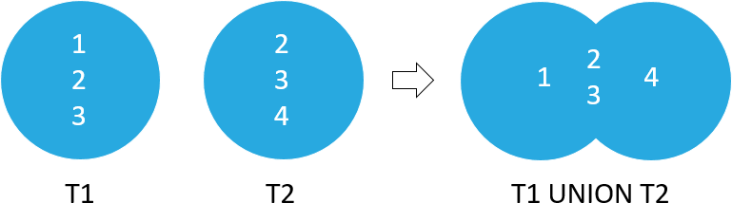

The following statement combines the result sets of t1 and t2 table using the  UNION ALL operator:

SELECT v1

FROM t1

UNION ALL

SELECT v2

FROM t2;

Code language: SQL (Structured Query Language) (sql)

The following picture shows the output:

SQLite UNION ALL example

The following picture illustrates the UNION ALL operation of the result sets of t1 and t2 tables:

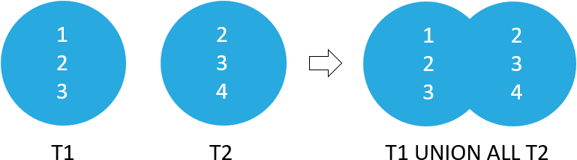

## SQLite UNION examples

Let’s take some examples of using the UNION operator.

### **1) SQLite UNION example**

This statement uses the UNION operator to combine names of employees and customers into a single list:

SELECT FirstName, LastName, 'Employee' AS Type

FROM employees

UNION

SELECT FirstName, LastName, 'Customer'

FROM customers;

Code language: SQL (Structured Query Language) (sql)

Here is the output:

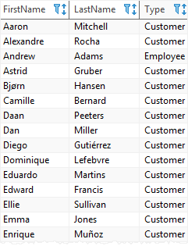

### **2) SQLite UNION with ORDER BY example**

This example uses the UNION operator to combine the names of the employees and customers into a single list. In addition, it uses the ORDER BY clause to sort the name list by first name and last name.

SELECT FirstName, LastName, 'Employee' AS Type

FROM employees

UNION

SELECT FirstName, LastName, 'Customer'

FROM customers

ORDER BY FirstName, LastName;

Code language: SQL (Structured Query Language) (sql)

Here is the output:

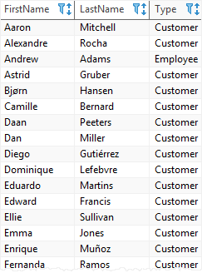

SQLite Except

**Summary**: in this tutorial, you will learn how to use the SQLite EXCEPT operator.

Introduction to SQLite EXCEPT operator

SQLite EXCEPT operator compares the result sets of two queries and returns distinct rows from the left query that are not output by the right query.

The following shows the syntax of the EXCEPT operator:

SELECT select_list1

FROM table1

EXCEPT

SELECT select_list2

FROM table2

Code language: SQL (Structured Query Language) (sql)

This query must conform to the following rules:

* First, the number of columns in the select lists of both queries must be the same.
* Second, the order of the columns and their types must be comparable.

The following statements [create two tables](https://www.sqlitetutorial.net/sqlite-create-table/) t1 and t2 and [insert](https://www.sqlitetutorial.net/sqlite-insert/) some data into both tables:

CREATE TABLE t1(

v1 INT

);

INSERT INTO t1(v1)

VALUES(1),(2),(3);

CREATE TABLE t2(

v2 INT

);

INSERT INTO t2(v2)

VALUES(2),(3),(4);

Code language: SQL (Structured Query Language) (sql)

The following statement illustrates how to use the EXCEPT operator to compare result sets of two queries:

SELECT v1

FROM t1

EXCEPT

SELECT v2

FROM t2;

Code language: SQL (Structured Query Language) (sql)

The output is 1.

The following picture illustrates the EXCEPT operation:

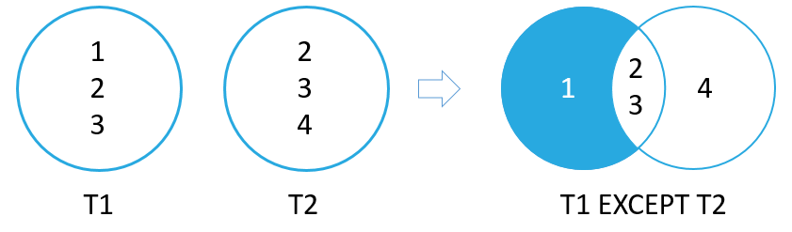

SQLite EXCEPT examples

We will use the artists and albums tables from the [sample database](https://www.sqlitetutorial.net/sqlite-sample-database/) for the demonstration.

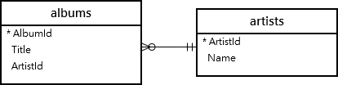

The following statement finds artist ids of artists who do not have any album in the albums table:

SELECT ArtistId

FROM artists

EXCEPT

SELECT ArtistId

FROM albums;

Code language: SQL (Structured Query Language) (sql)

The output is as follows:

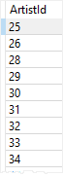

SQLite Intersect

**Summary**: in this tutorial, you will learn how to use the SQLite INTERSECT operator.

Introduction to SQLite INTERSECT operator

SQLite INTERSECT operator compares the result sets of two [queries](https://www.sqlitetutorial.net/sqlite-select/) and returns distinct rows that are output by both queries.

The following illustrates the syntax of the INTERSECT operator:

SELECT select_list1

FROM table1

INTERSECT

SELECT select_list2

FROM table2

Code language: SQL (Structured Query Language) (sql)

The basic rules for combining the result sets of two queries are as follows:

* First, the number and the order of the columns in all queries must be the same.
* Second, the data types must be comparable.

For the demonstration, we will [create two tables](https://www.sqlitetutorial.net/sqlite-create-table/) t1 and t2 and [insert some data](https://www.sqlitetutorial.net/sqlite-insert/) into both:

CREATE TABLE t1(

v1 INT

);

INSERT INTO t1(v1)

VALUES(1),(2),(3);

CREATE TABLE t2(

v2 INT

);

INSERT INTO t2(v2)

VALUES(2),(3),(4);

Code language: SQL (Structured Query Language) (sql)

The following statement illustrates how to use the INTERSECT operator to compare result sets of two queries:

SELECT v1

FROM t1

INTERSECT

SELECT v2

FROM t2;

Code language: SQL (Structured Query Language) (sql)

Here is the output:

SQLite INTERSECT operator example

The following picture illustrates the INTERSECT operation:

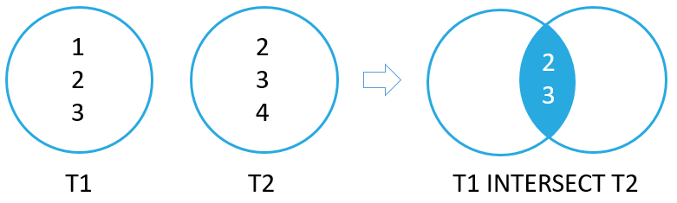

SQLite INTERSECT example

For the demonstration, we will use the customers and invoices tables from the [sample database](https://www.sqlitetutorial.net/sqlite-sample-database/).

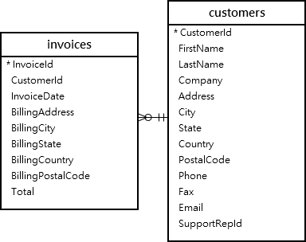

The following statement finds customers who have invoices:

SELECT CustomerId

FROM customers

INTERSECT

SELECT CustomerId

FROM invoices

ORDER BY CustomerId;

Code language: SQL (Structured Query Language) (sql)

The following picture shows the partial output:

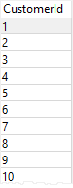

### **Grouping data**

# SQLite Group By

**Summary**: in this tutorial, you will learn how to use SQLite GROUP BY clause to make a set of summary rows from a set of rows.

## Introduction to SQLite GROUP BY clause

The GROUP BY clause is an optional clause of the [SELECT](https://www.sqlitetutorial.net/sqlite-select/) statement. The GROUP BY clause a selected group of rows into summary rows by values of one or more columns.

The GROUP BY clause returns one row for each group. For each group, you can apply an aggregate function such as [MIN](https://www.sqlitetutorial.net/sqlite-min/), [MAX](https://www.sqlitetutorial.net/sqlite-max/), [SUM](https://www.sqlitetutorial.net/sqlite-sum/), [COUNT](https://www.sqlitetutorial.net/sqlite-count-function/), or [AVG](https://www.sqlitetutorial.net/sqlite-avg/) to provide more information about each group.

The following statement illustrates the syntax of the SQLite GROUP BY clause.

SELECT

column_1,

aggregate_function(column_2)

FROM

table

GROUP BY

column_1,

column_2;

Code language: SQL (Structured Query Language) (sql)

The GROUP BY clause comes after the FROM clause of the SELECT statement. In case a statement contains a [WHERE](https://www.sqlitetutorial.net/sqlite-where/) clause, the GROUP BY clause must come after the WHERE clause.

Following the GROUP BY clause is a column or a list of comma-separated columns used to specify the group.

## SQLite GROUP BY examples

We use the tracks table from the [sample database](https://www.sqlitetutorial.net/sqlite-sample-database/) for the demonstration.



### **SQLite GROUP BY clause with COUNT function**

The following statement returns the album id and the number of tracks per album. It uses the GROUP BY clause to groups tracks by album and applies the [COUNT()](https://www.sqlitetutorial.net/sqlite-count-function/) function to each group.

SELECT

albumid,

COUNT(trackid)

FROM

tracks

GROUP BY

albumid;

Code language: SQL (Structured Query Language) (sql)

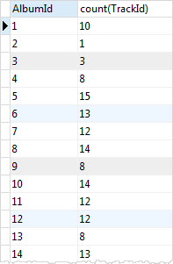

You can use the [ORDER BY](https://www.sqlitetutorial.net/sqlite-order-by/) clause to sort the groups as follows:

SELECT

albumid,

COUNT(trackid)

FROM

tracks

GROUP BY

albumid

ORDER BY COUNT(trackid) DESC;

Code language: SQL (Structured Query Language) (sql)

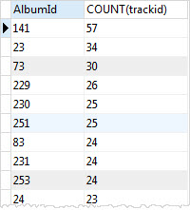

### **SQLite GROUP BY clause with SUM function example**

You can use the [SUM](https://www.sqlitetutorial.net/sqlite-sum/) function to calculate total per group. For example, to get total length and bytes for each album, you use the SUM function to calculate total milliseconds and bytes.

SELECT

albumid,

SUM(milliseconds) length,

SUM(bytes) size

FROM

tracks

GROUP BY

albumid;

Code language: SQL (Structured Query Language) (sql)

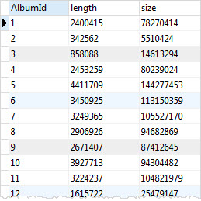

### **SQLite GROUP BY with MAX, MIN, and AVG functions**

The following statement returns the album id, album title, maximum length, minimum length, and the average length of tracks in the tracks table.

SELECT

tracks.albumid,

title,

min(milliseconds),

max(milliseconds),

round(avg(milliseconds),2)

FROM

tracks

INNER JOIN albums ON albums.albumid = tracks.albumid

GROUP BY

tracks.albumid;

Code language: SQL (Structured Query Language) (sql)

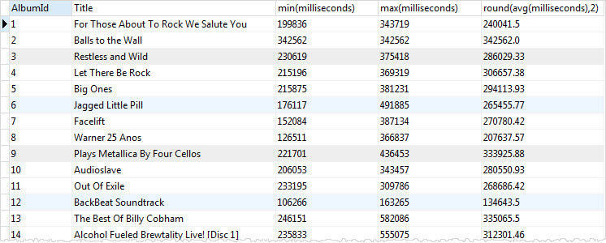

### **SQLite GROUP BY multiple columns example**

In the previous example, we have used one column in the GROUP BY clause. SQLite allows you to group rows by multiple columns.

For example, to group tracks by media type and genre, you use the following statement:

SELECT

MediaTypeId,

GenreId,

COUNT(TrackId)

FROM

tracks

GROUP BY

MediaTypeId,

GenreId;

Code language: SQL (Structured Query Language) (sql)

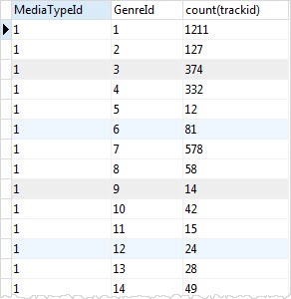

SQLite uses the combination of values of MediaTypeId and GenreId columns as a group e.g., (1,1) and (1,2). It then applies the [COUNT](https://www.sqlitetutorial.net/sqlite-count-function/) function to return the number of tracks in each group.

# SQLite Having

**Summary**: in this tutorial, you will learn how to use SQLite HAVING clause to specify a filter condition for a group or an aggregate.

## Introduction to SQLite HAVING clause

SQLite HAVING clause is an optional clause of the [SELECT](https://www.sqlitetutorial.net/sqlite-select/) statement. The HAVING clause specifies a search condition for a group.

You often use the HAVING clause with the [GROUP BY](https://www.sqlitetutorial.net/sqlite-group-by/) clause. The GROUP BY clause groups a set of rows into a set of summary rows or groups. Then the HAVING clause filters groups based on a specified condition.

If you use the HAVING clause, you must include the GROUP BY clause; otherwise, you will get the following error:

Error: a GROUP BY clause is required before HAVING

Code language: JavaScript (javascript)

Note that the HAVING clause is applied after GROUP BY clause, whereas the [WHERE](https://www.sqlitetutorial.net/sqlite-where/) clause is applied before the GROUP BY clause.

The following illustrates the syntax of the HAVING clause:

SELECT

column_1,

column_2,

aggregate_function (column_3)

FROM

table

GROUP BY

column_1,

column_2

HAVING

search_condition;

Code language: SQL (Structured Query Language) (sql)

In this syntax, the HAVING clause evaluates the search_condition for each group as a Boolean expression. It only includes a group in the final result set if the evaluation is true.

## SQLite HAVING clause examples

We will use the tracks table in the [sample database](https://www.sqlitetutorial.net/sqlite-sample-database/) for demonstration.



To find the number of tracks for each album, you use GROUP BY clause as follows:

SELECT

albumid,

COUNT(trackid)

FROM

tracks

GROUP BY

albumid;

Code language: SQL (Structured Query Language) (sql)

[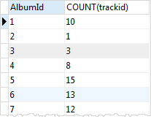](https://www.sqlitetutorial.net/wp-content/uploads/2015/12/SQLite-HAVING-clause-with-COUNT-function.jpg)

To find the numbers of tracks for the album with id 1, we add a HAVING clause to the following statement:

SELECT

albumid,

COUNT(trackid)

FROM

tracks

GROUP BY

albumid

HAVING albumid = 1;

SQLite HAVING with WHERE clause

We have referred to the AlbumId column in the HAVING clause.

To find albums that have the number of tracks between 18 and 20, you use the [aggregate function](https://www.sqlitetutorial.net/sqlite-aggregate-functions/) in the HAVING clause as shown in the following statement:

SELECT

albumid,

COUNT(trackid)

FROM

tracks

GROUP BY

albumid

HAVING

COUNT(albumid) BETWEEN 18 AND 20

ORDER BY albumid;

Code language: SQL (Structured Query Language) (sql)

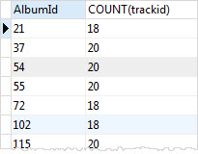

The following statement queries data from tracks and albums tables using [inner join](https://www.sqlitetutorial.net/sqlite-inner-join/) to find albums that have the total length greater than 60,000,000 milliseconds.

SELECT

tracks.AlbumId,

title,

SUM(Milliseconds) AS length

FROM

tracks

INNER JOIN albums ON albums.AlbumId = tracks.AlbumId

GROUP BY

tracks.AlbumId

HAVING

length > 60000000;

Code language: SQL (Structured Query Language) (sql)

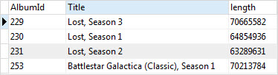

### **Sorting rows**

SQLite Order By

**Summary**: in this tutorial, you will learn how to sort a result set of a query using SQLite ORDER BY clause.

Introduction to SQLite ORDER BY clause

SQLite stores data in the tables in an unspecified order. It means that the rows in the table may or may not be in the order that they were inserted.

If you use the  [SELECT](https://www.sqlitetutorial.net/sqlite-select/) statement to query data from a table, the order of rows in the result set is unspecified.

To sort the result set, you add the ORDER BY clause to the  SELECT statement as follows:

SELECT

select_list

FROM

table

ORDER BY

column_1 ASC,

column_2 DESC;

Code language: SQL (Structured Query Language) (sql)

The ORDER BY clause comes after the FROM clause. It allows you to sort the result set based on one or more columns in ascending or descending order.

In this syntax, you place the column name by which you want to sort after the ORDER BY clause followed by the ASC or DESC keyword.

* The ASC keyword means ascending.
* And the DESC keyword means descending.

If you don’t specify the ASC or DESC keyword, SQLite sorts the result set using the ASC option. In other words, it sorts the result set in the ascending order by default.

In case you want to sort the result set by multiple columns, you use a comma (,) to separate two columns. The ORDER BY clause sorts rows using columns or expressions from left to right. In other words, the ORDER BY clause sorts the rows using the first column in the list. Then, it sorts the sorted rows using the second column, and so on.

You can sort the result set using a column that does not appear in the select list of the SELECT clause.

SQLite ORDER BY clause example

Let’s take the tracks table in the [sample database](https://www.sqlitetutorial.net/sqlite-sample-database/) for the demonstration.



Suppose, you want to get data from name, milliseconds, and album id columns, you use the following statement:

SELECT

name,

milliseconds,

albumid

FROM

tracks;

Code language: SQL (Structured Query Language) (sql)

[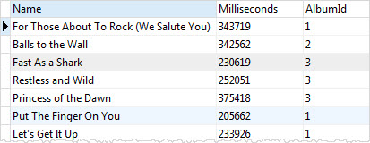](https://www.sqlitetutorial.net/wp-content/uploads/2015/11/tracks-table-data-without-sorting.jpg)

The SELECT statement that does not use ORDER BY clause returns a result set that is not in any order.

Suppose you want to sort the result set based on AlbumId column in ascending order, you use the following statement:

SELECT

name,

milliseconds,

albumid

FROM

tracks

ORDER BY

albumid ASC;

Code language: SQL (Structured Query Language) (sql)

[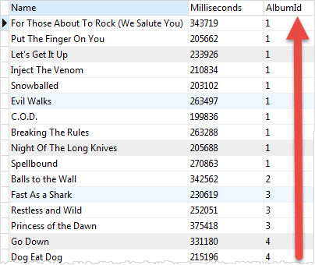](https://www.sqlitetutorial.net/wp-content/uploads/2015/11/SQLite-ORDER-BY-example.jpg)

The result set now is sorted by the AlbumId column in ascending order as shown in the screenshot.

SQLite uses ASC by default so you can omit it in the above statement as follows:

SELECT

name,

milliseconds,

albumid

FROM

tracks

ORDER BY

albumid;

Suppose you want to sort the sorted result (by AlbumId) above by the Milliseconds column in descending order. In this case, you need to add the Milliseconds column to the ORDER BY clause as follows:

SELECT

name,

milliseconds,

albumid

FROM

tracks

ORDER BY

albumid ASC,

milliseconds DESC;

Code language: SQL (Structured Query Language) (sql)

[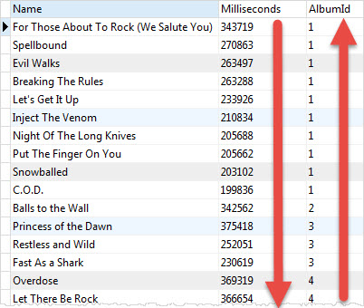](https://www.sqlitetutorial.net/wp-content/uploads/2015/11/SQLite-ORDER-BY-multiple-columns-example.jpg)

SQLite sorts rows by AlbumId column in ascending order first. Then, it sorts the sorted result set by the Milliseconds column in descending order.

If you look at the tracks of the album with AlbumId 1, you find that the order of tracks changes between the two statements.

SQLite ORDER BY with the column position

Instead of specifying the names of columns, you can use the column’s position in the ORDER BY clause.

For example, the following statement sorts the tracks by both albumid (3rd column) and milliseconds (2nd column) in ascending order.

SELECT

name,

milliseconds,

albumid

FROM

tracks

ORDER BY

3,2;

Code language: SQL (Structured Query Language) (sql)

The number 3 and 2 refers to the AlbumId and Milliseconds in the column list that appears in the SELECT clause.

[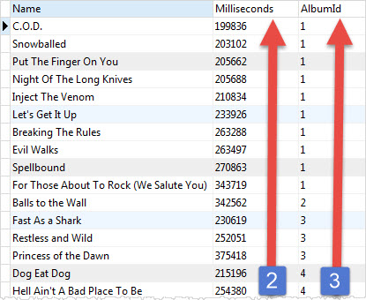](https://www.sqlitetutorial.net/wp-content/uploads/2015/11/SQLite-ORDER-BY-multiple-columns-by-positions.jpg)

Sorting NULLs

In the database world, NULL is special. It denotes that the information missing or the data is not applicable.

Suppose you want to store the birthday of an artist in a table. At the time of saving the artist’s record, you don’t have the birthday information.

To represent the unknown birthday information in the database, you may use a special date like 01.01.1900 or an '' empty string. However, both of these values do not clearly show that the birthday is unknown.

NULL was invented to resolve this issue. Instead of using a special value to indicate that the information is missing, NULL is used.

NULL is special because you cannot compare it with another value. Simply put, if the two pieces of information are unknown, you cannot compare them.

NULL is even cannot be compared with itself; NULL is not equal to itself so NULL = NULL always results in false.

When it comes to sorting, SQLite considers NULL to be smaller than any other value.

It means that NULLs will appear at the beginning of the result set if you use ASC or at the end of the result set when you use DESC.

SQLite 3.30.0 added the NULLS FIRST and NULLS LAST options to the ORDER BY clause. The NULLS FIRST option specifies that the NULLs will appear at the beginning of the result set while the NULLS LAST option place NULLs at the end of the result set.

The following example uses the ORDER BY clause to sort tracks by composers:

SELECT

TrackId,

Name,

Composer

FROM

tracks

ORDER BY

Composer;

Code language: SQL (Structured Query Language) (sql)

First, you see that NULLs appear at the beginning of the result set because SQLite treats them as the lowest values. When you scroll down the result, you will see other values:

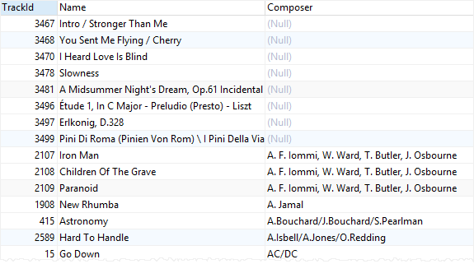

The following example uses the NULLS LAST option to place NULLs after other values:

SELECT

TrackId,

Name,

Composer

FROM

tracks

ORDER BY

Composer NULLS LAST;

Code language: SQL (Structured Query Language) (sql)

If you scroll down the output, you will see that NULLs are placed at the end of the result set:

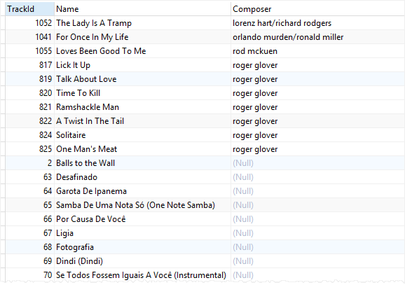

### **More querying techniques**

# SQLite CASE

**Summary:**in this tutorial, you will learn about the SQLite CASE expression to add the conditional logic to a query.

The SQLite CASE expression evaluates a list of conditions and returns an expression based on the result of the evaluation.

The CASE expression is similar to the IF-THEN-ELSE statement in other programming languages.

You can use the CASE expression in any clause or statement that accepts a valid expression. For example, you can use the CASE expression in clauses such as [WHERE](https://www.sqlitetutorial.net/sqlite-where/), [ORDER BY](https://www.sqlitetutorial.net/sqlite-order-by/), [HAVING](https://www.sqlitetutorial.net/sqlite-having/), [SELECT](https://www.sqlitetutorial.net/sqlite-select/) and statements such as [SELECT](https://www.sqlitetutorial.net/sqlite-select/), [UPDATE](https://www.sqlitetutorial.net/sqlite-update/), and [DELETE](https://www.sqlitetutorial.net/sqlite-delete/).

SQLite provides two forms of the CASE expression: simple CASE and searched CASE.

## SQLite simple CASE expression

The simple CASE expression compares an expression to a list of expressions to return the result. The following illustrates the syntax of the simple CASE expression.

CASE case_expression

WHEN when_expression_1 THEN result_1

WHEN when_expression_2 THEN result_2

...

[ ELSE result_else ]

END

Code language: SQL (Structured Query Language) (sql)

The simple CASE expression compares the case_expression to the expression appears in the first WHEN clause, when_expression_1, for equality.

If the case_expression equals when_expression_1, the simple CASE returns the expression in the corresponding THEN clause, which is the result_1.

Otherwise, the simple CASE expression compares the case_expression with the expression in the next WHEN clause.

In case no case_expression matches the when_expression, the CASE expression returns the result_else in the ELSE clause. If you omit the ELSE clause, the CASE expression returns NULL.

The simple CASE expression uses short-circuit evaluation. In other words, it returns the result and stop evaluating other conditions as soon as it finds a match.

### **Simple CASE example**

Let’s take a look at the customers table in the [sample database](https://www.sqlitetutorial.net/sqlite-sample-database/).

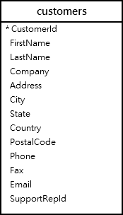

Suppose, you have to make a report of the customer groups with the logic that if a customer locates in the USA, this customer belongs to the domestic group, otherwise the customer belongs to the foreign group.

To make this report, you use the simple CASE expression in the SELECT statement as follows:

SELECT customerid,

firstname,

lastname, country,

CASE country

WHEN 'USA'

THEN 'Domestic'

ELSE 'Foreign'

END CustomerGroup

FROM

customers

ORDER BY

LastName,

FirstName;

Code language: SQL (Structured Query Language) (sql)

## SQLite searched CASE expression

The searched CASE expression evaluates a list of expressions to decide the result. Note that the simple CASE expression only compares for equality, while the searched CASE expression can use any forms of comparison.

The following illustrates the syntax of the searched CASE expression.

CASE

WHEN bool_expression_1 THEN result_1

WHEN bool_expression_2 THEN result_2

[ ELSE result_else ]

END

Code language: SQL (Structured Query Language) (sql)

The searched CASE expression evaluates the Boolean expressions in the sequence specified and return the corresponding result if the expression evaluates to true.

In case no expression evaluates to true, the searched CASE expression returns the expression in the ELSE clause if specified. If you omit the ELSE clause, the searched CASE expression returns NULL.

Similar to the simple CASE expression, the searched CASE expression stops the evaluation when a condition is met.

### **Searched CASE example**

We will use the tracks table for the demonstration.



Suppose you want to classify the tracks based on its length such as less a minute, the track is short; between 1 and 5 minutes, the track is medium; greater than 5 minutes, the track is long.

To achieve this, you use the searched CASE expression as follows:

SELECT

trackid,

name,milliseconds,

CASE

WHEN milliseconds < 60000 THEN

'short'

WHEN milliseconds > 60000 AND milliseconds < 300000 THEN 'medium'

ELSE

'long'

END category

FROM

Tracks;

Code language: SQL (Structured Query Language) (sql)

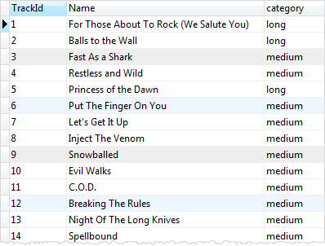

### **Joining tables**

# SQLite Join

**Summary**: in this tutorial, you will learn about various kinds of SQLite joins to query data from two or more tables.

For the demonstration, we will use the artists and albums tables from the [sample database](https://www.sqlitetutorial.net/sqlite-sample-database/).



An artist can have zero or many albums while an album belongs to one artist.

To query data from both artists and albums tables, you use can use an [INNER JOIN](https://www.sqlitetutorial.net/sqlite-inner-join/), [LEFT JOIN](https://www.sqlitetutorial.net/sqlite-left-join/), or [CROSS JOIN](https://www.sqlitetutorial.net/sqlite-cross-join/) clause. Each join clause determines how SQLite uses data from one table to match with rows in another table.

Note that SQLite doesn’t directly support the RIGHT JOIN and [FULL OUTER JOIN](https://www.sqlitetutorial.net/sqlite-full-outer-join/).

## SQLite INNER JOIN

The following statement returns the album titles and their artist names:

SELECT

Title,

Name

FROM

albums

INNER JOIN artists

ON artists.ArtistId = albums.ArtistId limit 5;

Code language: SQL (Structured Query Language) (sql)

Here is the partial output:

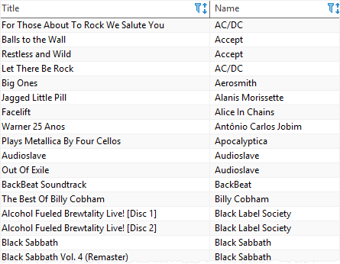

In this example, the INNER JOIN clause matches each row from the albums table with every row from the artists table based on the join condition (artists.ArtistId = albums.ArtistId) specified after the ON keyword.

If the join condition evaluates to true (or 1), the columns of rows from both albums and artists tables are included in the result set.

This query uses table aliases (l for the albums table and r for artists table) to shorten the query:

SELECT

l.Title,

r.Name

FROM

albums l

INNER JOIN artists r ON

r.ArtistId = l.ArtistId limit 5;

Code language: SQL (Structured Query Language) (sql)

In case the column names of joined tables are the same e.g., ArtistId, you can use the USING syntax as follows:

SELECT

Title,

Name

FROM

albums

INNER JOIN artists USING(ArtistId);

Code language: SQL (Structured Query Language) (sql)

The clause USING(ArtistId) is equipvalent to the clause ON artists.ArtistId = albums.ArtistId.

## SQLite LEFT JOIN

This statement selects the artist names and album titles from the artists and albums tables using the LEFT JOIN clause:

SELECT

Name,

Title

FROM

artists

LEFT JOIN albums ON

artists.ArtistId = albums.ArtistId

ORDER BY Name limit 5;

Code language: SQL (Structured Query Language) (sql)

Here is the output:

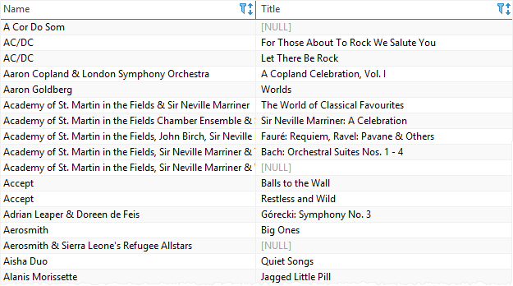

The LEFT JOIN clause selects data starting from the left table (artists) and matching rows in the right table (albums) based on the join condition (artists.ArtistId = albums.ArtistId) .

The left join returns all rows from the artists table (or left table) and the matching rows from the albums table (or right table).

If a row from the left table doesn’t have a matching row in the right table, SQLite includes columns of the rows in the left table and NULL for the columns of the right table.

Similar to the INNER JOIN clause, you can use the USING syntax for the join condition as follows:

SELECT

Name,

Title

FROM

artists

LEFT JOIN albums USING (ArtistId)

ORDER BY

Name;

Code language: SQL (Structured Query Language) (sql)

If you want to find artists who don’t have any albums, you can add a [WHERE](https://www.sqlitetutorial.net/sqlite-where/) clause as shown in the following query:

SELECT

Name,

Title

FROM

artists

LEFT JOIN albums ON

artists.ArtistId = albums.ArtistId

WHERE Title IS NULL

ORDER BY Name;

Code language: SQL (Structured Query Language) (sql)

This picture shows the partial output:

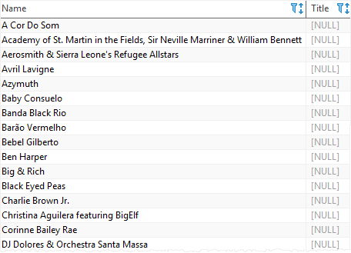

Generally, this type of query allows you to find rows that are available in the left table but don’t have corresponding rows in the right table.

Note that LEFT JOIN and LEFT OUTER JOIN are synonyms.

## SQLite CROSS JOIN

The CROSS JOIN clause creates a [Cartesian product](https://en.wikipedia.org/wiki/Cartesian_product) of rows from the joined tables.

Unlike the INNER JOIN and LEFT JOIN clauses, a CROSS JOIN doesn’t have a join condition. Here is the basic syntax of the CROSS JOIN clause:

SELECT

select_list

FROM table1

CROSS JOIN table2;

Code language: SQL (Structured Query Language) (sql)

The CROSS JOIN combines every row from the first table (table1) with every row from the second table (table2) to form the result set.

If the first table has N rows, the second table has M rows, the final result will have NxM rows.

A practical example of the CROSS JOIN clause is to combine two sets of data for forming an initial data set for further processing. For example, you have a list of products and months, and you want to make a plan when you can sell which products.

The following script creates the products and calendars tables:

CREATE TABLE products(

product text NOT null

);

INSERT INTO products(product)

VALUES('P1'),('P2'),('P3');

CREATE TABLE calendars(

y int NOT NULL,

m int NOT NULL

);

INSERT INTO calendars(y,m)

VALUES

(2019,1),

(2019,2),

(2019,3),

(2019,4),

(2019,5),

(2019,6),

(2019,7),

(2019,8),

(2019,9),

(2019,10),

(2019,11),

(2019,12);

Code language: SQL (Structured Query Language) (sql)

This query uses the CROSS JOIN clause to combine the products with the months:

SELECT *

FROM products

CROSS JOIN calendars;

Code language: SQL (Structured Query Language) (sql)

Here is the output:

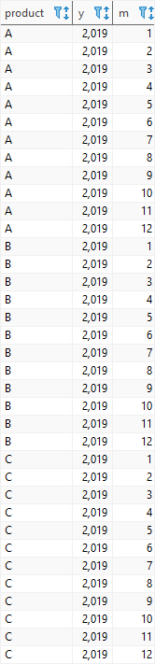

# SQLite Inner Join

**Summary**: this tutorial shows you how to use SQLite inner join clause to query data from multiple tables.

## Introduction to SQLite inner join clause

In relational databases, data is often distributed in many related tables. A table is associated with another table using [foreign keys](https://www.sqlitetutorial.net/sqlite-foreign-key/).

To [query data](https://www.sqlitetutorial.net/sqlite-select/) from multiple tables, you use INNER JOIN clause. The INNER JOIN clause combines columns from correlated tables.

Suppose you have two tables: A and B.

A has a1, a2, and f columns. B has b1, b2, and f column. The A table links to the B table using a foreign key column named f.

The following illustrates the syntax of the inner join clause:

SELECT a1, a2, b1, b2

FROM A

INNER JOIN B on B.f = A.f;

Code language: SQL (Structured Query Language) (sql)

For each row in the A table, the INNER JOIN clause compares the value of the f column with the value of the f column in the B table. If the value of the f column in the A table equals the value of the f column in the B table, it combines data from a1, a2, b1, b2, columns and includes this row in the result set.

In other words, the INNER JOIN clause returns rows from the A table that has the corresponding row in B table.

This logic is applied if you join more than 2 tables.

See the following example.

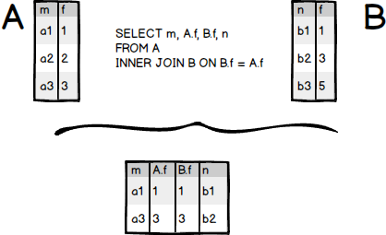

Only the rows in the A table: (a1,1), (a3,3) have the corresponding rows in the B table (b1,1), (b2,3) are included in the result set.

The following diagram illustrates the INNER JOIN clause:

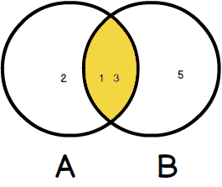

## SQLite INNER JOIN examples

Let’s take a look at the tracks and albums tables in the [sample database](https://www.sqlitetutorial.net/sqlite-sample-database/). The tracks table links to the albums table via AlbumId column.

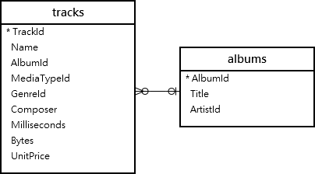

In the tracks table, the AlbumId column is a foreign key. And in the albums table, the AlbumId is the [primary key](https://www.sqlitetutorial.net/sqlite-primary-key/).

To query data from both tracks and albums tables, you use the following statement:

SELECT

trackid,

name,

title

FROM

tracks

INNER JOIN albums ON albums.albumid = tracks.albumid;

Code language: SQL (Structured Query Language) (sql)

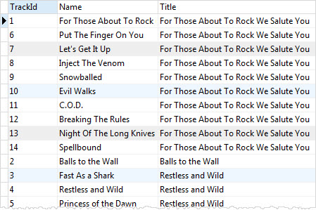

For each row in the tracks table, SQLite uses the value in the albumid column of the tracks table to compare with the value in the albumid of the albums table. If SQLite finds a match, it combines data of rows in both tables in the result set.

You can include the AlbumId columns from both tables in the final result set to see the effect.

SELECT

trackid,

name,

tracks.albumid AS album_id_tracks,

albums.albumid AS album_id_albums,

title

FROM

tracks

INNER JOIN albums ON albums.albumid = tracks.albumid;

Code language: SQL (Structured Query Language) (sql)

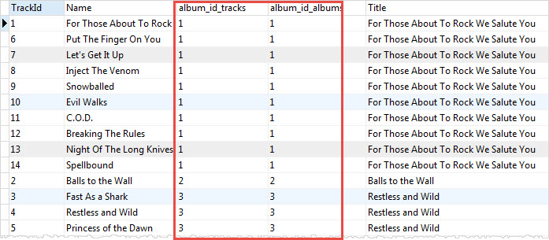

### **SQLite inner join – 3 tables example**

See the following tables:tracks albums and artists

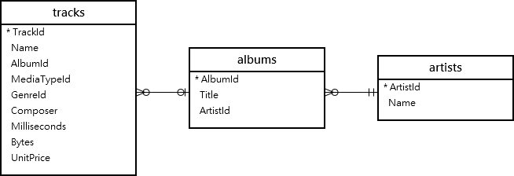

One track belongs to one album and one album have many tracks. The tracks table associated with the albums table via albumid column.

One album belongs to one artist and one artist has one or many albums. The albums table links to the artists table via artistid column.

To query data from these tables, you need to use two inner join clauses in the [SELECT](https://www.sqlitetutorial.net/sqlite-select/) statement as follows:

SELECT

trackid,

tracks.name AS track,

albums.title AS album,

artists.name AS artist

FROM

tracks

INNER JOIN albums ON albums.albumid = tracks.albumid

INNER JOIN artists ON artists.artistid = albums.artistid limit 5;

Code language: SQL (Structured Query Language) (sql)

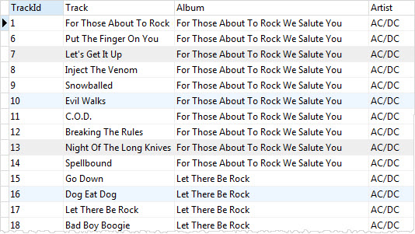

You can use a [WHERE clause](https://www.sqlitetutorial.net/sqlite-where/) to get the tracks and albums of the artist with id 10 as the following statement:

SELECT

trackid,

tracks.name AS Track,

albums.title AS Album,

artists.name AS Artist

FROM

tracks

INNER JOIN albums ON albums.albumid = tracks.albumid

INNER JOIN artists ON artists.artistid = albums.artistid

WHERE

artists.artistid = 10;

Code language: SQL (Structured Query Language) (sql)

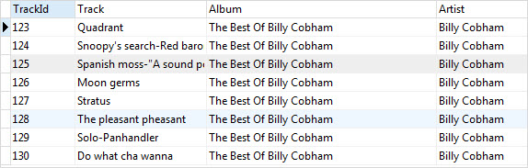

# SQLite CROSS JOIN with a Practical Example

**Summary**: in this tutorial, you will learn how to use SQLite CROSS JOIN to combine two or more result sets from multiple tables.

## Introduction to SQLite CROSS JOIN clause

If you use a [LEFT JOIN](https://www.sqlitetutorial.net/sqlite-left-join/), [INNER JOIN](https://www.sqlitetutorial.net/sqlite-inner-join/), or CROSS JOIN without the ON or USING clause, SQLite produces the [Cartesian product](https://en.wikipedia.org/wiki/Cartesian_product) of the involved tables. The number of rows in the Cartesian product is the product of the number of rows in each involved tables.

Suppose, we have two tables A and B. The following statements perform the cross join and produce a cartesian product of the rows from the A and B tables.

SELECT *

FROM A JOIN B;

Code language: SQL (Structured Query Language) (sql)

SELECT *

FROM A

INNER JOIN B;

Code language: SQL (Structured Query Language) (sql)

SELECT *

FROM A

CROSS JOIN B;

Code language: SQL (Structured Query Language) (sql)

SELECT *

FROM A, B;

Code language: SQL (Structured Query Language) (sql)

Suppose, the A table has N rows and B table has M rows, the CROSS JOIN of these two tables will produce a result set that contains NxM rows.

Imagine that if you have the third table C with K rows, the result of the CROSS JOIN clause of these three tables will contain NxMxK rows, which may be very huge. Therefore, you should be very careful when using the CROSS JOIN clause.

You use the INNER JOIN and LEFT JOIN clauses more often than the CROSS JOIN clause. However, you will find the CROSS JOIN clause very useful in some cases.

For example, when you want to have a matrix that has two dimensions filled with data completely like members and dates data in a membership database. You want to check the attendants of members for all relevant dates. In this case, you may use the CROSS JOIN clause as the following statement:

SELECT name,

date

FROM members

CROSS JOIN dates;

Code language: SQL (Structured Query Language) (sql)

## SQLite CROSS JOIN clause example

The following statements create the ranks and suits tables that store the ranks and suits for a deck of cards and insert the complete data into these two tables.

CREATE TABLE ranks (

rank TEXT NOT NULL

);

CREATE TABLE suits (

suit TEXT NOT NULL

);

INSERT INTO ranks(rank)

VALUES('2'),('3'),('4'),('5'),('6'),('7'),('8'),('9'),('10'),('J'),('Q'),('K'),('A');

INSERT INTO suits(suit)

VALUES('Clubs'),('Diamonds'),('Hearts'),('Spades');

Code language: SQL (Structured Query Language) (sql)

The following statement uses the CROSS JOIN clause to return a complete deck of cards data:

SELECT rank,

suit

FROM ranks

CROSS JOIN

suits

ORDER BY suit;

Code language: SQL (Structured Query Language) (sql)

| **rank** | **suit** |
| --- | --- |
| 2 | Clubs |
| 3 | Clubs |
| 4 | Clubs |
| 5 | Clubs |
| 6 | Clubs |
| 7 | Clubs |
| 8 | Clubs |
| 9 | Clubs |
| 10 | Clubs |
| J | Clubs |
| Q | Clubs |
| K | Clubs |
| A | Clubs |
| 2 | Diamonds |
| 3 | Diamonds |
| 4 | Diamonds |
| 5 | Diamonds |
| 6 | Diamonds |
| 7 | Diamonds |
| 8 | Diamonds |
| 9 | Diamonds |
| 10 | Diamonds |
| J | Diamonds |
| Q | Diamonds |
| K | Diamonds |
| A | Diamonds |
| 2 | Hearts |
| 3 | Hearts |
| 4 | Hearts |
| 5 | Hearts |
| 6 | Hearts |
| 7 | Hearts |
| 8 | Hearts |
| 9 | Hearts |
| 10 | Hearts |
| J | Hearts |
| Q | Hearts |
| K | Hearts |
| A | Hearts |
| 2 | Spades |
| 3 | Spades |
| 4 | Spades |
| 5 | Spades |
| 6 | Spades |
| 7 | Spades |
| 8 | Spades |
| 9 | Spades |
| 10 | Spades |
| J | Spades |
| Q | Spades |
| K | Spades |
| A | Spades |

SQLite Self-Join

**Summary**: in this tutorial, you will learn about a special type of join called SQLite self-join that allows you to join table to itself.

Note that you should be familiar with  [INNER JOIN](https://www.sqlitetutorial.net/sqlite-inner-join/) and [LEFT JOIN](https://www.sqlitetutorial.net/sqlite-left-join/) clauses before going forward with this tutorial.

Introduction to SQLite self-join

The self-join is a special kind of joins that allow you to join a table to itself using either LEFT JOIN or INNER JOIN clause. You use self-join to create a result set that joins the rows with the other rows within the same table.

Because you cannot refer to the same table more than one in a query, you need to use a table alias to assign the table a different name when you use self-join.

The self-join compares values of the same or different columns in the same table. Only one table is involved in the self-join.

You often use self-join to query parents/child relationship stored in a table or to obtain running totals.

SQLite self-join examples

We will use the employees table in the [sample database](https://www.sqlitetutorial.net/sqlite-sample-database/) for demonstration.

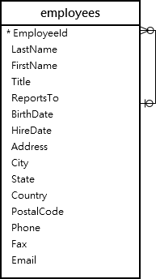

The employees table stores not only employee data but also organizational data. The ReportsTo column specifies the reporting relationship between employees.

If an employee reports to a manager, the value of the ReportsTo column of the employee’s row is equal to the value of the EmployeeId column of the manager’s row. In case an employee does not report to anyone, the ReportsTo column is NULL.

To get the information on who is the direct report of whom, you use the following statement:

SELECT m.firstname || ' ' || m.lastname AS 'Manager',

e.firstname || ' ' || e.lastname AS 'Direct report'

FROM employees e

INNER JOIN employees m ON m.employeeid = e.reportsto

ORDER BY manager;

Code language: SQL (Structured Query Language) (sql)

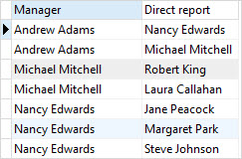

The statement used the INNER JOIN clause to join the employees to itself. The employees table has two roles: employees and managers.

Because we used the INNER JOIN clause to join the employees table to itself, the result set does not have the row whose manager column contains a NULL value.

Note that the [concatenation operator](https://www.sqlitetutorial.net/sqlite-string-functions/sqlite-concat/) || concatenates multiple strings into a single string. In the example, we use the concatenation operator to from the full names of the employees by concatenating the first name, space, and last name.

In case you want to query the CEO who does not report to anyone, you need to change the INNER JOIN clause to LEFT JOIN clause in the query above.

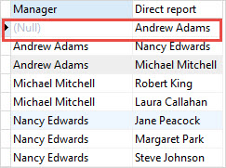

Andrew Adams is the CEO because he does not report anyone.

You can use the self-join technique to find the employees located in the same city as the following query:

SELECT DISTINCT

e1.city,

e1.firstName || ' ' || e1.lastname AS fullname

FROM

employees e1

INNER JOIN employees e2 ON e2.city = e1.city

AND (e1.firstname <> e2.firstname AND e1.lastname <> e2.lastname)

ORDER BY

e1.city;

Code language: SQL (Structured Query Language) (sql)

[**Try It**](https://www.sqlitetutorial.net/tryit/query/sqlite-self-join/#2)

[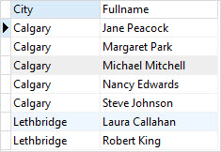](https://www.sqlitetutorial.net/wp-content/uploads/2015/12/SQLite-self-join-employees-locate-in-the-same-city.jpg)

The join condition has two expressions:

* e1.city = e2.city to make sure that both employees located in the same city
* e.firstname <> e2.firstname AND e1.lastname <> e2.lastname to ensure that e1 and e2 are not the same employee with the assumption that there aren’t employees who have the same first name and last name.

SQLite FULL OUTER JOIN Emulation

**Summary**: in this tutorial, you will learn how to emulate SQLite full outer join using the UNION and LEFT JOIN clauses.

Introduction to SQL FULL OUTER JOIN clause

In theory, the result of the FULL OUTER JOIN is a combination of  a [LEFT JOIN](https://www.sqlitetutorial.net/sqlite-left-join/) and a RIGHT JOIN. The result set of the full outer join has NULL values for every column of the table that does not have a matching row in the other table. For the matching rows, the FULL OUTER JOIN produces a single row with values from columns of the rows in both tables.

The following picture illustrates the result of the FULL OUTER JOIN clause:

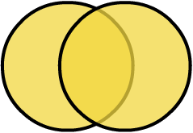

See the following cats and dogs tables.

-- create and insert data into the dogs table

CREATE TABLE dogs (

type TEXT,

color TEXT

);

INSERT INTO dogs(type, color)

VALUES('Hunting','Black'), ('Guard','Brown');

-- create and insert data into the cats table

CREATE TABLE cats (

type TEXT,

color TEXT

);

INSERT INTO cats(type,color)

VALUES('Indoor','White'),

('Outdoor','Black');

Code language: SQL (Structured Query Language) (sql)

The following statement uses the FULL OUTER JOIN clause to query data from the dogs and cats tables.

SELECT *

FROM dogs

FULL OUTER JOIN cats

ON dogs.color = cats.color;

Code language: SQL (Structured Query Language) (sql)

The following shows the result of the statement above:

| **Type** | **Color** | **Type** | **Color** |
| --- | --- | --- | --- |
| Hunting | Black | Outdoor | Black |
| Guard | Brown | NULL | NULL |
| NULL | NULL | Indoor | White |

Unfortunately, SQLite does not support the RIGHT JOIN clause and also the FULL OUTER JOIN clause. However, you can easily emulate the FULL OUTER JOIN by using the LEFT JOIN clause.

Emulating SQLite full outer join

The following statement emulates the FULL OUTER JOIN clause in SQLite:

SELECT d.type,

d.color,

c.type,

c.color

FROM dogs d

LEFT JOIN cats c USING(color)

UNION ALL

SELECT d.type,

d.color,

c.type,

c.color

FROM cats c

LEFT JOIN dogs d USING(color)

WHERE d.color IS NULL;

Code language: SQL (Structured Query Language) (sql)

How the query works.

* Because SQLilte does not support the RIGHT JOIN clause, we use the [LEFT JOIN](https://www.sqlitetutorial.net/sqlite-left-join/) clause in the second [SELECT](https://www.sqlitetutorial.net/sqlite-select/) statement instead and switch the positions of the cats and dogs tables.
* The [UNION ALL](https://www.sqlitetutorial.net/sqlite-union/) clause retains the duplicate rows from the result sets of both queries.
* The WHERE clause in the second SELECT statement removes rows that already included in the result set of the first SELECT statement.

In this tutorial, you have learned how to use the UNION ALL and LEFT JOIN clauses to emulate the SQLite FULL OUTER JOIN clause.

# SQLite Trigger

**Summary**: this tutorial discusses SQLite trigger, which is a database object fired automatically when the data in a table is changed.

## What is an SQLite trigger

An SQLite trigger is a named database object that is executed automatically when an [INSERT](https://www.sqlitetutorial.net/sqlite-insert/), [UPDATE](https://www.sqlitetutorial.net/sqlite-update/) or [DELETE](https://www.sqlitetutorial.net/sqlite-delete/) statement is issued against the associated table.

## When do we need SQLite triggers

You often use triggers to enable sophisticated auditing. For example, you want to log the changes in the sensitive data such as salary and address whenever it changes.

In addition, you use triggers to enforce complex business rules centrally at the database level and prevent invalid transactions.

## SQLite CREATE TRIGGER statement

To create a new trigger in SQLite, you use the CREATE TRIGGER statement as follows:

CREATE TRIGGER [IF NOT EXISTS] trigger_name

[BEFORE|AFTER|INSTEAD OF] [INSERT|UPDATE|DELETE]

ON table_name

[WHEN condition]

BEGIN

statements;

END;

Code language: SQL (Structured Query Language) (sql)

In this syntax:

* First,  specify the name of the trigger after the CREATE TRIGGER keywords.
* Next, determine when the trigger is fired such as BEFORE, AFTER, or [INSTEAD OF](https://www.sqlitetutorial.net/sqlite-instead-of-triggers/). You can create BEFORE and AFTER triggers on a table. However, you can only create an [INSTEAD OF](https://www.sqlitetutorial.net/sqlite-instead-of-triggers/) trigger on a view.
* Then, specify the event that causes the trigger to be invoked such as INSERT, UPDATE, or DELETE.
* After that, indicate the table to which the trigger belongs.
* Finally, place the trigger logic in the BEGIN END block, which can be any valid SQL statements.

If you combine the time when the trigger is fired and the event that causes the trigger to be fired, you have a total of 9 possibilities:

* BEFORE INSERT
* AFTER INSERT
* BEFORE UPDATE
* AFTER UPDATE
* BEFORE DELETE
* AFTER DELETE
* INSTEAD OF INSERT
* INSTEAD OF DELETE
* INSTEAD OF UPDATE

Suppose you use a UPDATE statement to update 10 rows in a table, the trigger that associated with the table is fired 10 times. This trigger is called FOR EACH ROW trigger. If the trigger associated with the table is fired one time, we call this trigger a FOR EACH STATEMENT trigger.

As of version 3.9.2, SQLite only supports FOR EACH ROW triggers. It has not yet supported the FOR EACH STATEMENT triggers.

If you use a condition in the WHEN clause, the trigger is only invoked when the condition is true. In case you omit the WHEN clause, the trigger is executed for all rows.

Notice that if you [drop a table](https://www.sqlitetutorial.net/sqlite-drop-table/), all associated triggers are also deleted. However, if the trigger references other tables, the trigger is not removed or changed if other tables are removed or updated.

For example, a trigger references to a table named people, you drop the people table or rename it, you need to manually change the definition of the trigger.

You can access the data of the row being inserted, deleted, or updated using the OLD and NEW references in the form: OLD.column_name and NEW.column_name.

the OLD and NEW references are available depending on the event that causes the trigger to be fired.

The following table illustrates the rules.:

| **Action** | **Reference** |
| --- | --- |
| INSERT | NEW is available |
| UPDATE | Both NEW and OLD are available |
| DELETE | OLD is available |

## SQLite triggers examples

Let’s [create a new table](https://www.sqlitetutorial.net/sqlite-create-table/) called leads to store all business leads of the company.

CREATE TABLE leads (

id integer PRIMARY KEY,

first_name text NOT NULL,

last_name text NOT NULL,

phone text NOT NULL,

email text NOT NULL,

source text NOT NULL

);

Code language: SQL (Structured Query Language) (sql)

### **1) SQLite BEFORE INSERT trigger example**

Suppose you want to validate the email address before inserting a new lead into the leads table. In this case, you can use a BEFORE INSERT trigger.

First, create a BEFORE INSERT trigger as follows:

CREATE TRIGGER validate_email_before_insert_leads

BEFORE INSERT ON leads

BEGIN

SELECT

CASE

WHEN NEW.email NOT LIKE '%_@__%.__%' THEN

RAISE (ABORT,'Invalid email address')

END;

END;

Code language: SQL (Structured Query Language) (sql)

We used the NEW reference to access the email column of the row that is being inserted.

To validate the email, we used the [LIKE](https://www.sqlitetutorial.net/sqlite-like/) operator to determine whether the email is valid or not based on the email pattern. If the email is not valid, the RAISE function aborts the insert and issues an error message.

Second, insert a row with an invalid email into the leads table.

INSERT INTO leads (first_name,last_name,email,phone)

VALUES('John','Doe','jjj','4089009334');

Code language: SQL (Structured Query Language) (sql)

SQLite issued an error: “Invalid email address” and aborted the execution of the insert.

Third, insert a row with a valid email.

INSERT INTO leads (first_name, last_name, email, phone, source)

VALUES ('John', 'Doe', 'john.doe@sqlitetutorial.net', '4089009334',’data’);

Code language: SQL (Structured Query Language) (sql)

Because the email is valid, the insert statement executed successfully.

SELECT

first_name,

last_name,

email,

phone

FROM

leads;

Code language: SQL (Structured Query Language) (sql)

SQLite TRIGGER Leads Table

### **2) SQLite AFTER UPDATE trigger example**

The phones and emails of the leads are so important that you can’t afford to lose this information. For example, someone accidentally updates the email or phone to the wrong ones or even delete it.

To protect this valuable data, you use a trigger to log all changes which are made to the phone and email.

First, [create a new table](https://www.sqlitetutorial.net/sqlite-create-table/) called lead_logs to store the historical data.

CREATE TABLE lead_logs (

id INTEGER PRIMARY KEY,

old_id int,

new_id int,

old_phone text,

new_phone text,

old_email text,

new_email text,

user_action text,

created_at text

);

Code language: SQL (Structured Query Language) (sql)

Second, create an AFTER UPDATE trigger to log data to the lead_logs table whenever there is an update in the email or phone column.

CREATE TRIGGER log_contact_after_update

AFTER UPDATE ON leads

WHEN old.phone <> new.phone

OR old.email <> new.email

BEGIN

INSERT INTO lead_logs (

old_id,

new_id,

old_phone,

new_phone,

old_email,

new_email,

user_action,

created_at

)

VALUES

(

old.id,

new.id,

old.phone,

new.phone,

old.email,

new.email,

'UPDATE',

DATETIME('NOW')

) ;

END;

Code language: SQL (Structured Query Language) (sql)

You notice that in the condition in the WHEN clause specifies that the trigger is invoked only when there is a change in either email or phone column.

Third, update the last name of John from Doe to Smith.

UPDATE leads

SET

last_name = 'Smith'

WHERE

id = 1;

Code language: SQL (Structured Query Language) (sql)

The trigger log_contact_after_update was not invoked because there was no change in email or phone.

Fourth, update both email and phone of John to the new ones.

UPDATE leads

SET

phone = '4089998888',

email = 'john.smith@sqlitetutorial.net'

WHERE

id = 1;

Code language: SQL (Structured Query Language) (sql)

If you check the log table, you will see there is a new entry there.

SELECT

old_phone,

new_phone,

old_email,

new_email,

user_action

FROM

lead_logs;

Code language: SQL (Structured Query Language) (sql)

SQLite TRIGGER After Update Trigger Example

You can develop the AFTER INSERT and AFTER DELETE triggers to log the data in the lead_logs table as an excercise.

## SQLite DROP TRIGGER statement

To drop an existing trigger, you use the DROP TRIGGER statement as follows:

DROP TRIGGER [IF EXISTS] trigger_name;

Code language: SQL (Structured Query Language) (sql)

In this syntax:

* First, specify the name of the trigger that you want to drop after the DROP TRIGGER keywords.
* Second, use the IF EXISTS option to delete the trigger only if it exists.

Note that if you drop a table, SQLite will automatically drop all triggers associated with the table.

For example, to remove the validate_email_before_insert_leads trigger, you use the following statement:

DROP TRIGGER validate_email_before_insert_leads;